Classification of Malignancy in Tumours

A Data Science and Machine Learning Approach

Wilson, Benjamin Isaac

Leeds Beckett univerisity

Table of Contents

Abstract 3

Introduction 3

1. Literature review on Machine Learning Principles and Applications. 3

1.1 Applications of Machine Learning 3

1.2 The Project Context and Application to a Business 4

1.3 Implementation of Analysis From Using Visualisation Techniques 4

1.4 Key Terms of Machine Learning 5

2. Tools and Technologies that are being used for the process 6

2.1 Python and Some Other Options 6

2.2 The Python Data Science Stack 6

2.2.1 Python Data Stack Module Descriptions 7

2.3 The Jupyter Notebook Environment 7

2.4 GitHub Version Control System 8

3. Methodology - Cross-industry Standard Process for Data Mining 8

4. Data Understanding and Considerations 9

4.1 Cancer Growth Represented by Continuous Variables 9

4.2 Differing Unit Scales and Its Effects 10

4.3 Imbalanced Datasets and the Accuracy Paradox 10

5. Data Preparation 11

5.1 Removing Irrelevant Items 11

5.2 Encoding the Categorical Values 11

5.3 Scaling the Data Using Zero Mean 12

6. Exploration and Feature Selection using Visualisation 13

6.1 Subplots and Histograms 14

6.2 Dimensionality Reduction using Principle Component Analysis 16

6.3 Building the Principle Components 17

6.4 Analysing the Principle Components 18

6.4.1 Correlation Heatmaps with Principle Components 18

6.4.2 Score Plot of the Principal Components 18

6.4.3 Feature Relations Analysis Using a Biplot 20

6.5 Supplementary Heatmaps plots for feature Correlation analysis 22

6.6 The Final Selected Features 23

7. Training and Testing of Performance Metrics Results 23

7.1 Accuracy Metric and its Flaws 24

7.2 Solutions to the Accuracy Paradox 24

7.2.1 Resampling the Data 24

7.2.2 Using Precision and Recall Metrics 26

7.3 Cross-Validation of the Performance Using Stratified Kfolds 27

7.4 Fine Tuning Thresholds Using Receiver Operating Characteristic 28

Evaluation 29

Future Work and Conclusions 30

Reflection on Learning 31

Appendices 32

A. Supporting Documents of Professional Approach 32

B. Evaluation Results 33

C. Project Management 35

D. Document Repositories and Code 36

1. Project Set up and Data Dictionary 36

2. Data Pre-processing and Preparation 37

3. Data Exploration and Visualisation 37

4. Testing 39

References 39

Word Count : 8685

# Abstract

This report focuses on the aspects of data science and machine learning to feature engineer a dataset to develop a predictive model the can be implemented into a Clinical Decision Support System(CDSS). It will outline typical workflows and methodologies of analysis and development of classification models using a common data science stack. A further reason for attempting this project is that it could provide insight into how data science and AI can give a much-needed boost to efficiency in diagnostics. Furthermore, finding out how these systems might be diffused or are diffusing into society will be part of the success of the final system.

# Introduction

Main techniques explored are within Exploratory Data Analysis(EDA) or “data understanding”, of which includes visualisation of the data to obtain insights into what types of machine learning algorithms might be suitable(or not) for the problem and what features are the most relevant to the identification of to cancer by looking at separations between each class of cancer and seeing if there might be any underlying considerations needed. Data preparation, where the data is cleaned and formatted. Processes include scaling and normalising for accurate correlations. Feature selection and engineering after further EDA, this includes dropping irrelevant features. Splitting the data into a training and test set for supervised machine learning and looking at cross-validation for improved reliability.

Initial objectives of the project encompass building a machine-learned binary classification model to predict whether a breast tumour growth is Malignant or Benign using the characteristics and features of the cell nuclei present in a screening image i.e the finding of the EDA process. The process involves various data science techniques to explore the data and understand its features, meta-features and structure in order to produce a reliable automated predictive analysis that has potential to aid diagnosis.

Further objectives are identifying the potential use cases of the model. This is critical in accessing risk factors that might come with the automated diagnosis using the appropriate metrics and morals. This includes the ethics of using computer models to assess the risk of human life based on the model's effectiveness using a variety of metrics such as predictive accuracy, precision, recall and *f1*-scores. This is an attempt to enlighten beneficiaries and stakeholders to the usage of machine learning and data science. For example, hospital directors might wish to see the benefits and drawbacks to applying these types of models and also perhaps show how it could be applied not just to cancer diagnostics but other areas as well.

# 1. Literature review on Machine Learning Principles and Applications.

## 1.1 Applications of Machine Learning

One of the biggest topics of recent times is the use of computers to make predictions that might make the lives of people easier. Machine Learning is a major buzzword that has been thrown about in many industries looking to improve services, profits and scientific pursuits These industries include but are not limited to:

1. Data Security
2. Personal Security
3. Finacial Trading
4. Healthcare
5. Marketing Personalisation
6. Fraud Detection
7. Online Recommendations
8. Online Searching
9. Natural Language Processing(NLP)
10. Smart Cars(Automation)

Machine Learning is extracting knowledge from data and producing predictive models without explicitly programming them. Synonyms include predictive analytics or statistical learning. The field intersects between statistics, artificial intelligence and computer science. Real world examples of implementations include Netflix’s movie recommendation system, Amazon’s product recommendation system and Google Ads.(Marr, 2016).

## 1.2 The Project Context and Application to a Business

The context of this project is healthcare, specifically how machine learning is used to develop models for Clinical Decision Support System (CDSS). The literature used for business understanding looked at who might be interested in using the system and what requirements need to be met. The model that is being built would demonstrate a fundamental component of a CDSS that could aid healthcare professionals to more effectively classify tumours needing further assessment. This hopefully can help better the precious time that patients may need and relieve pressure from medical practise.

The precursor to these types of systems started in 1972 to support clinical decisions around the cause of acute abdominal pain. The system was called AAPHelp and was developed in the UK but such systems were never put into mainstream service. The system ran on 1970s hardware which took a substantial amount of processing time for a single diagnosis but did outclass in accuracy with a 8.2% error rate as opposed to a senior clinicians 20.4% Showing statistical promise(Dombal, de et al., 1972), which leads on to the consideration that the system should be highly accurate. It should attempt to capture all instances that may pose a risk, as to minimise negative misdiagnosis. Better certainty is crucial to make better decisions. This will help the patient comfortable being assessed by a computer as one could feel like a statistic rather than a patient needing care. The system needs to outperform clinicians in correctly diagnosing issues but should be treated as an aid to the clinician otherwise the system is rendered useless and unappealing(Johnson, 2016).

The book **Guide to Health Informatics** provides a contextual grounding for why these systems *are* used and how one goes about accessing and using healthcare data to build CDSSs(Coiera, 2015). It goes on to talk about how CDSSs are aids to a human counterpart that can allow for more confident decisions with regards to making sure patients get the right care, discovering new patterns in data that might previously have been unknown that could be of relevance to better diagnosis and allowing more efficient pathways of care in an establishment.

## 1.3 Implementation of Analysis From Using Visualisation Techniques

On the topic of implementation, to produce a viable machine-learned model, visualisation becomes a fundamental part of understanding how the data may be used(or not used). In other words, they allow for the easy digestion of data so that an individual can deduce relevant information on complex and/or large amounts of data. The main book that has been a core component of the research is **Data analysis with open source tools: a hands-on guide for programmers and data scientists**(Janert, 2011)**.** It has provided information on what types of visualisations are suitable for many different scenarios. Specifically, It has provided insight into particular techniques deployed by data analysts and scientists for an analysis for a project of this kind. This includes Principal Component Analysis, Histograms scatter plots and correlation heatmaps/matrices. Supplementary to this, the book **Exploratory Data Analysis**(Tukey, 1977) has given a grounding idea of how to conduct such visual elements of the project and the importance their importance when looking at a data structure or lack of.

For the process of the project and the technical aspect, two books have been instrumental to understand Python and its core machine learning components. The first book to mention is **Introduction to Machine Learning in Python**(Müller, 2016) and the second **Hands-on Machine Learning with Scikit-Learn and TensorFlow**(Géron, 2017)**.** They both contain fundamental information on how to approach a machine learning project with examples of how to apply certain analytical and machine learning methods for building intelligent systems.

## 1.4 Key Terms of Machine Learning

Within the field there are important terms to remember such as;

* **Features** – Depending on the professional background, features are correlative to terms like fields, columns or attributes. These describe the characteristics of instances.
* **Instances** – These are correlative to the terms like rows, data points, observation, case or value.
* **Target** – This is correlative to the terms predicted, dependent variable or outcome. These are what determine the class of an instance.

There are two main types of machine learning, **Supervised** and **Unsupervised**. Both of which have various applications.

* **Supervised** methods describe that the algorithm expects data with features *and a* target to correlate with the attributes as input, with the model being the output(Figure 1). In other words, a dataset that contains the attributes(features) and what class(label) those attributes belong to for each instance. Such as if an animal has a trunk, 4 legs, a weight around 5400kg and the class(target) is Elephant, the machine would take those inputs and learn that elephants have a trunk, 4 legs and a general described weight. The output model might then be able to predict whether new unclassified data points are Elephants or not. The same process could work for predicting potential drug success based on what drugs have been successful or not in the past based on its attributes.
* **Unsupervised** methods describe a process that takes data input *without* a target to aim for. This method relies purely on the machine to deduce new information that might not have been previously known. For example, it might be that feeding an unlabeled dataset as input would an output of previously unknown clusters that could infer new possible classifications. The use case for this might be that you want to find new information about something that does not have a current classification, such as new trend patterns. This new information could be about trying to find new groups of people for target marketing by seeing similarities between them that were previously unknown. This method can also aid in understanding the data’s structure, allowing for better insight into what algorithms and features would best suit the classification problem. This is demonstrated later on using a technique called Principal Component Analysis(PCA).

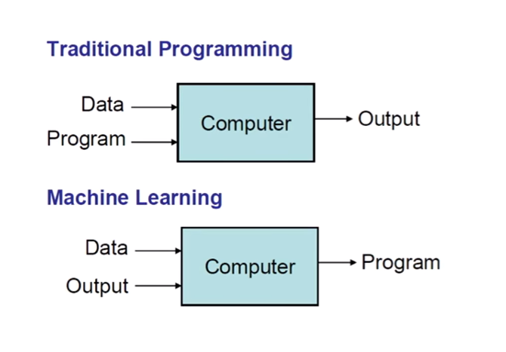

Figure Depicting the difference between traditional programming and machine learning outcomes (Grimson, 2017).

# 2. Tools and Technologies that are being used for the process

## 2.1 Python and Some Other Options

There are many choices of technology and software that are available to take on this kind of project. Python(Rossum, 1995), a general-purpose programming language has taken up a leading position in the data science community and is considered the “swiss army knife” of the field. This Is because of the vast amounts of modules available that have been developed for handling data and doing AI(PyData, n.d.). It has extensive documentation that makes the language accessible to a broad audience, allowing not just computer science professionals to use it, but also other professionals in many other fields which can make for better collaborative work if necessary(Reymond, 2017). There are other options such as R(R Core Team, 2013), SAS(SAS, n.d.) or SPSS(IBM, n.d.) that are popular, but Python is seen as one of the most accessible and dynamic languages used by many data science professionals and that user base continues to grow(Akiwatkar, 2017) so Python seems the most suitable for the project scope.

## 2.2 The Python Data Science Stack

As mentioned, Python has a bunch of modules that can be installed to provide robust data handling functionality. Because of this, the community has taken the effort to build their own distributions of python specifically tailored to data science and machine learning. **Anaconda**(Anaconda, n.d.) is one such distribution that packages the necessary modules for doing analytics in python and they offer a lightweight version called **Miniconda** which contains the main package manager **Conda** allowing the user to build their own data science stack from the shell, this reduces the size and complexity of the files(Alexander, 2017). Miniconda was chosen because of this.

The modules used were installed in the command shell (Figure 2);



Figure The command to install the modules that are used in the project.

### 2.2.1 Python Data Stack Module Descriptions

* **NumPy** – This module was installed because of many of the other modules depend on it. NumPy provides high-performance scientific computation functions to Python. Built by using Cython to implement N-dimensional array objects that are better performing than their pure python counterparts. It also has C/C++ and Fortran code integration and linear algebra capabilities used in Sckit-Learn(Oliphant, 2018).
* **Scikit-Learn** – This is a free open-source library that provides access to state-of-the-art machine learning algorithms. It implements an extension of python called Cython(Behnel et al., 2011) which wraps high performance of low-level C code within the simplistic syntax of Python. The library also provides useful tools for various for pre-processing functions for tasks such scaling data and encoding, performance metrics for model evaluation and dimensionality reduction for visualization and efficiency improvements(Pedregosa et al., 2011).
* **Pandas** – A module that handles datasets using what is called a DataFrame. It allows for ‘SQL like’ functionality to intuitively manipulate dataset. It comes with various statistical functions that can aid analysis. It has helped Python become a popular data science language since it integrates well with a lot of other scientific computing modules and has a lot of development support as features are frequently added and improved on. It is seen as a foundational layer in the Python data science stack(McKinney, 2011).
* **Matplotlib** – A 2D graphics library for python that is focused on allowing users to create graphical plots that are publication suitable. Its interface can provide an easy way to plot information in a presentable manner. It was initially developed to emulate MATLAB(2018b) graphics capabilities independent of MATLAB. It has become a matured heavyweight in the data science community allowing for customizable plotting in an object-oriented way within python. It relies on high-performance code extensions such as NumPy to better interact with large arrays of data(Hunter, 2007).
* **Seaborn** – An extension built on top of Matplotlib that provides easier access to certain plots, tools for choosing colour palettes, functions for analysing univariate and bivariate distributions or comparisons between subsets of data and high-level abstractions for grid plots. It integrates with the Python data stack including Pandas and NumPy(Waskom, 2012).

The code used to include the relevant object can be found at Appendix D in Project Set up and Data Dictionary.

## 2.3 The Jupyter Notebook Environment

For the development and analysis environment, **Jupyter Notebook** was used. It is an interactive tool that runs in browser and interfaces with **IPython** along with other languages. IPython is an interactive shell for Python that allows for python code to be executed in code blocks interactively. It has been widely used by data analysts and data scientists(Pérez & Granger, 2007). It has the capability to produce high-quality reports that users can interact with using Python allowing for a dynamic analysis (Figure 3)(Müller, 2016, p. 7). It has integrated documentation lookups on a lot of the components of Python which is handy for quickly understanding the code and auto-completion. Jupyter with IPython can also implement text and images to supplement code and visualisations. Another feature is that the notebook files can be displayed online via GitHub as the site supports that format(Thomas et al., 2016, pp. 87–90).

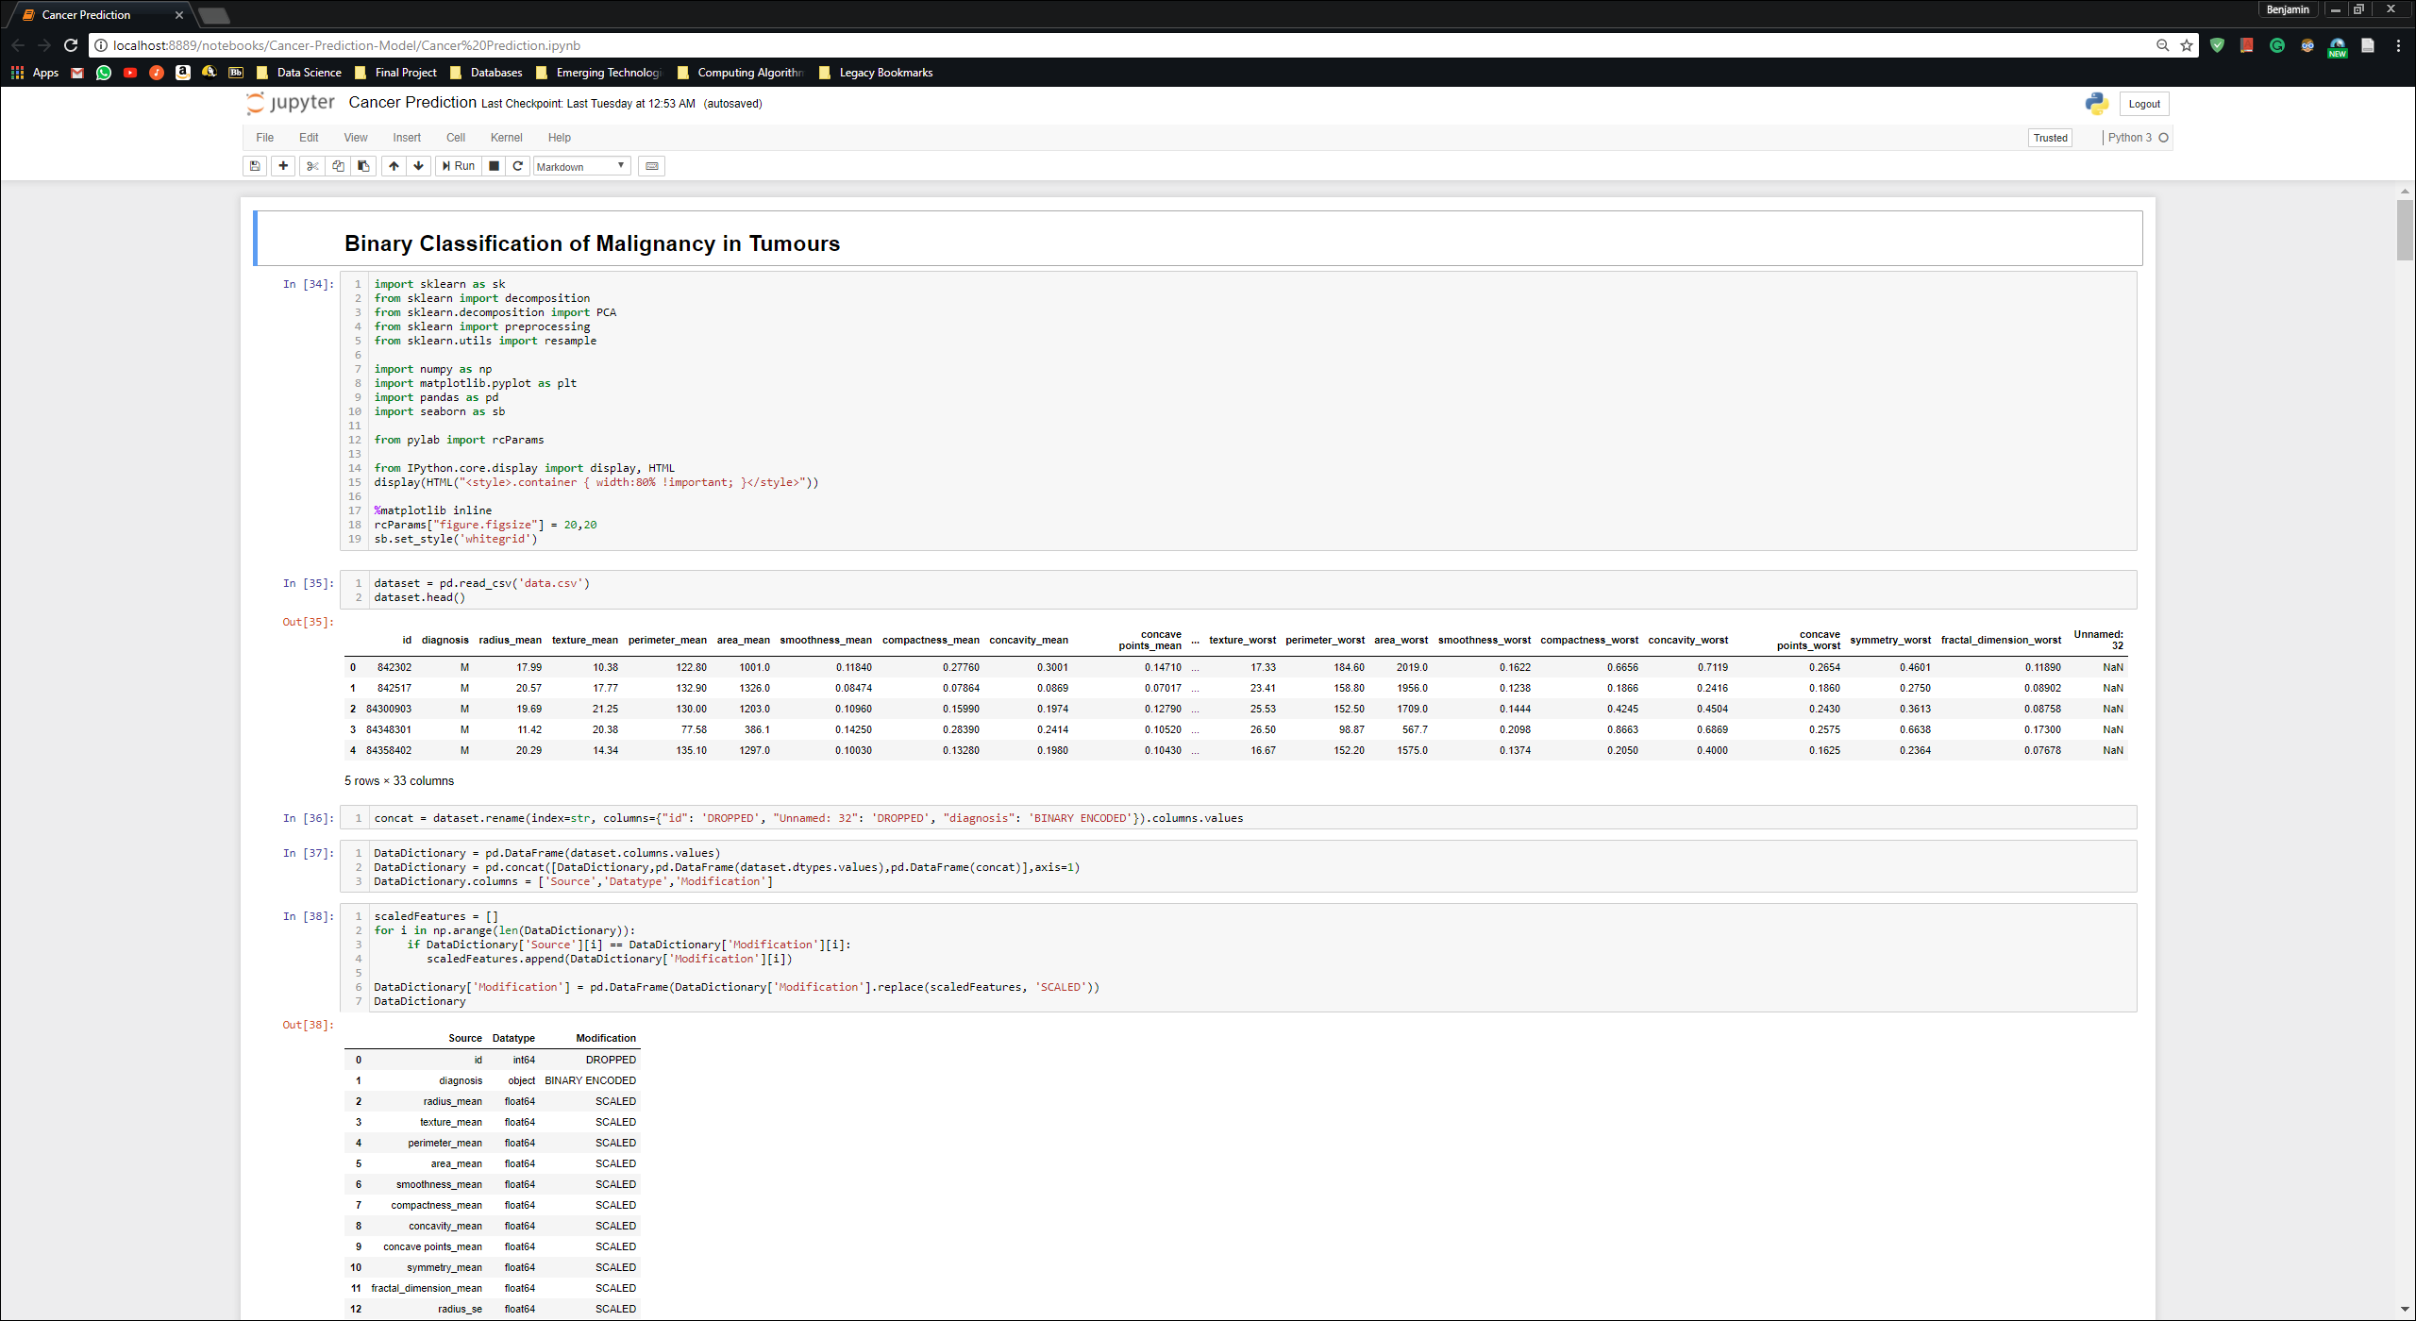

Figure The Jupyter Notebook Environment. It produces interactive reports that can include code that may be modified and executed interactively.

## 2.4 GitHub Version Control System

During the project was important to keep track of the progress by constantly pushing versions or completed tasks into some version control and for this GitHub was chosen. Backups are key to ensuring the project had minimal chance of disruption that may be caused by unforeseen circumstances and GitHub offers a secure method of doing so. The next valuable feature is that the developer can make comments on each version pushed which can help keep track of findings and progress(GitHub, n.d.). See Appendix D for repository link.

3. Methodology - Cross-industry Standard Process for Data Mining

To build these machine-learned models, the **Cross-Industry Standard Process for Data Mining** (CRISP-DM)(Figure 4) has been a suitable methodology and has been lightly adapted to the field of data science(Rollins, 2015)(Figure 5). It describes a cyclic and iterative process of trial and error when analysing data.

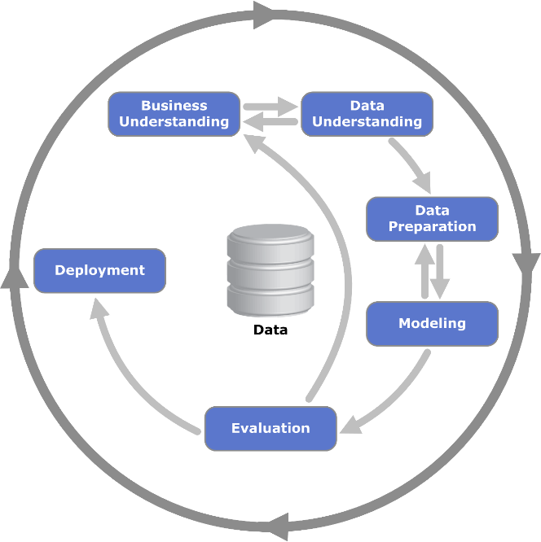

Figure A methodology called the Cross-industry standard process for data mining or CRISP-DM(Wikipedia, 2017b).

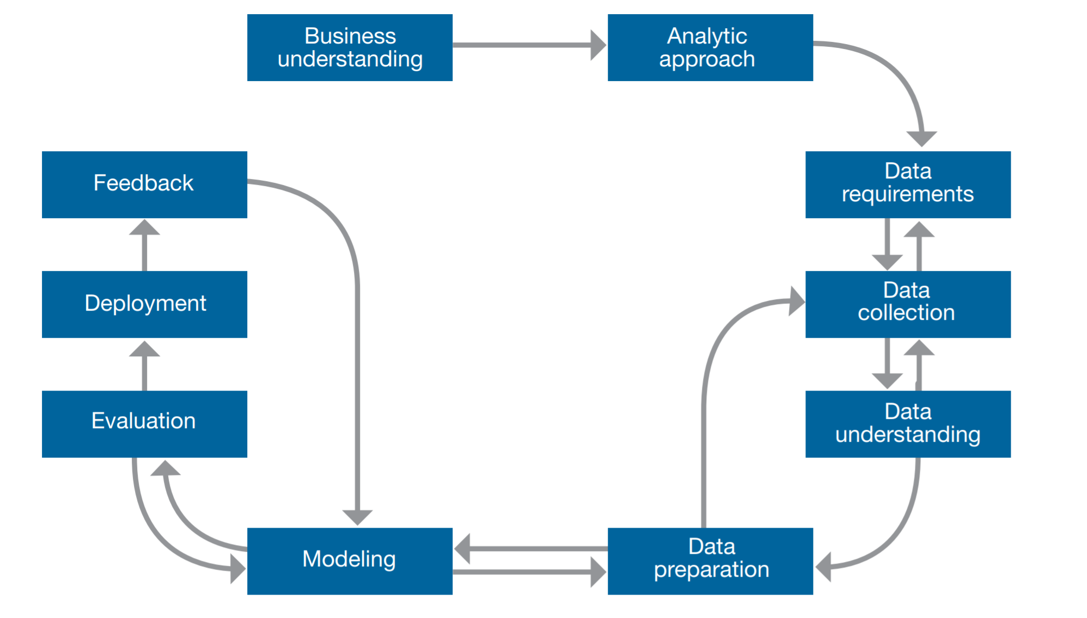

Figure CRISP-DM methodology adapted for Data Science (Rollins, 2015).

For this analysis, the original method will be followed as not all elements are needed or applicable for this process, such as further data collection. To try to gauge the workflow, a diagram describing the key findings and tasks for each stage was developed and maintained to keep track of the findings which can be found in Appendix A.

# 4. Data Understanding and Considerations

The next step, **Data Understanding** focuses on data collection, how the data is structured, the quality of the data and looking at the metadata. It is important to understand the context of the data and why the features are described a certain way. For example, a dataset may be comprised of features and targets of categorical values or continuous values or a mixture both. Feature names may give a clue about relations of the features and unit variance between them or perhaps give an idea as to what techniques should be used for doing the analysis(Wirth, 2000).

## 4.1 Cancer Growth Represented by Continuous Variables

For this dataset, the features are represented as continuous variables that measure the characteristics of the growth. These values have been pulled from digitized images of Fine Needle Aspirate(FNL) biopsy method (example in Figure 6) and enumerated to create the dataset. The target is a binary value represented by categories of ‘M’ for malignant and ‘B’ for benign. Further understanding is that the higher the value of the features the more likely the instance in malignant. This would make sense as the measurements represent growth and amount of abnormality.

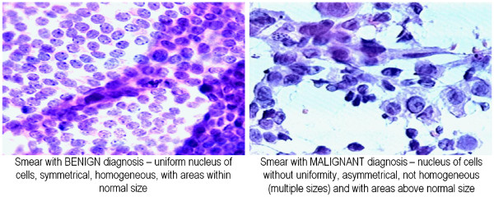

Figure Example of the types of images the data has been created from. It shows a comparison of benign and malignant growths(Sizilio et al., 2012).

Quality wise, there were no issues aside from a column called ‘**Unnamed: 32**’ that needed to be dropped as is contained nothing. Another column that was dropped was an id column that contained surrogate keys, therefore is not a useful statistical value.

The data source link can be found in Appendix D.

## 4.2 Differing Unit Scales and Its Effects

Looking at the names of the features, they each have three kinds of measurements of the features. These are ‘mean’, ‘standard error’ and ‘worst’ i.e. the feature called ‘texture’ has three variants, ‘texture_mean’, ‘texture_se’ and ‘texture_worst’. Because of this, the data has different unit ranges where the values represent different metrics. This is important to note because when doing the analysis and training, the analytical methods used in this project work in Euclidian Distance to figure out differences between data points in Euclidian Space(Danielsson, 1980), meaning that different unit types will have different proportional effects when doing certain visualisations or when training the or when training certain classifiers. In other words, some values may have different scales and some machine learning algorithms such as SVM, K-nearest neighbours, and logistic regression don’t handle varying scales well(2018a). Values may skew visuals unfavourably like when doing a PCA, making analysis unrepresentative of the true relationships between features(Buja et al., 2008; Géron, 2017, p. 66; Müller, 2016, pp. 134–135).

## 4.3 Imbalanced Datasets and the Accuracy Paradox

Further understanding revealed that the data is imbalanced (Figure 7). The dataset has a minority (Malignant cases) and majority class (Benign cases). Imbalanced datasets can skew accuracy performance. This can be referred to as the **Accuracy Paradox**(Wikipedia, 2017a). What happens is that the machine learning algorithm is accuracy focussed and assumes that a dataset input will be balanced(Brownlee, 2015). This means the accuracy is biased towards the majority class. For example, if an example dataset contains a class ratio of **10:90**, the classifier would be good at classifying the majority (the 90 instances) thus the accuracy would be representative of the majority which does not represent the performance of minority classification very well as it only denotes a higher accuracy because of the majority class. The goal is to obtain a high accuracy for every class. Some more examples of where this effect needs to be considered are fraud detection where many of the transactions may be normal and only a small percentage may be a risk. Another such example, perhaps an assembly line might want to detect defective components which would normally be a smaller percentage.

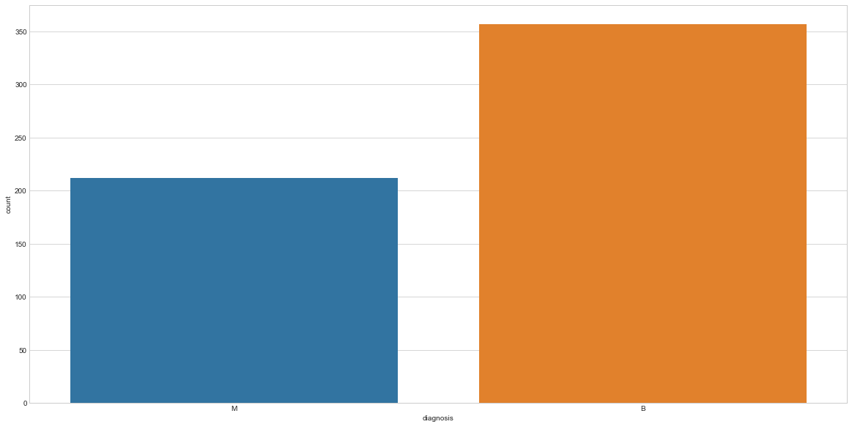

Figure Histogram showing the balance between classes. Notice the majority class accounts for around 66% or two-thirds of the data.

# 5. Data Preparation

After some understanding of the data, preparation of the data took place. This is done to allow for accurate analysis and compatibility with the machine learning functions of Scikit-learn. The process involves many steps. The first of which was to clean and drop any irrelevant data.

## 5.1 Removing Irrelevant Items

As mentioned in the data understanding, there were two columns (‘id’ and ‘Unnamed: 32’) that had no value to the analysis. These were dropped using the following code;



It simply calls the drop method for a pandas DataFrame object and passes the list of the columns that need to be dropped.

## 5.2 Encoding the Categorical Values

Next step was to encode the binary target ‘diagnosis’ from its string values of ‘M’ and ‘B’ to 0 and 1 respectively. The function used is called **LabelEncoder** from Scikit Learns pre-processing utilities;



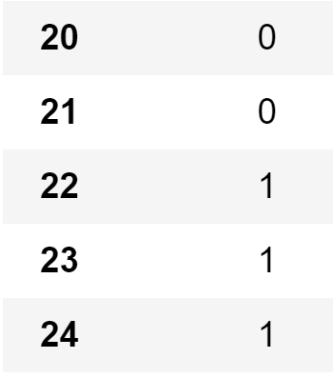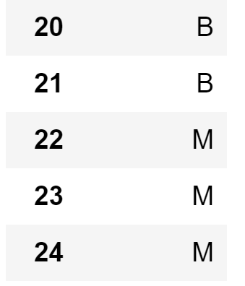What this function does is numerically encode categorical values between 0 and $n$ categories. In this case, $n = 1$ since it is a binary classification so the diagnosis is now encoded to 0 where ‘B’ and 1 where ‘M’(see Figure 8 and Figure 9).

Another option would be to use the **OneHotEncoding** function which encodes using a binary digit that sits in orthogonal vectors for identification. This can be more applicable to more algorithms as it allows for absolute separation between categories, avoiding the issue of an algorithm assuming a natural ordering between ordinal values which LabelEncoder produces. Both functions would achieve the same results in this case as there are only two classes but if dealing with more dimensions OneHotEncoding would gain an advantage because of this.

Figure After encoding.

Figure Before encoding.

## 5.3 Scaling the Data Using Zero Mean

The StandardScaler function is used to eliminate unit variance between features. It does this by using a zero-mean method which as described by the name shifts the mean for each feature to zero and unit variance. Calculating this is to determine the distribution mean as well as the standard deviation for each feature column, subtract the mean from each feature then dividing the values of each feature by its standard deviation (see Figure 10).

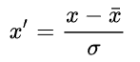

Figure Formula for Standardization

Here is an example of the code. It gets the scaler object and then calls the fit_transform method passing in the DataFrame;

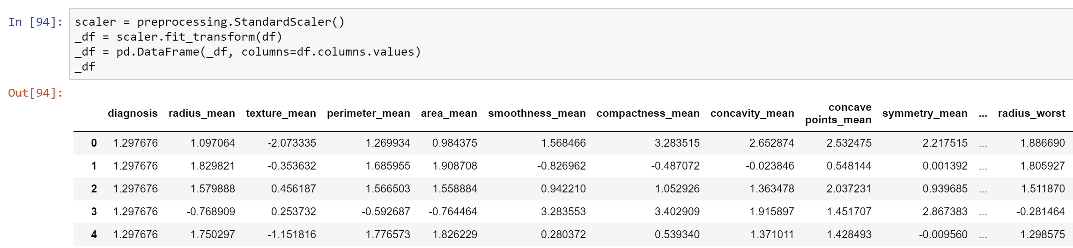

As seen, the attributes are all now scaled accordingly. The reason for choosing this method is that it is widely used by many machine learning algorithms(Grus, 2015, pp. 99–100) with the PCA algorithm specifically being the reason in this project.

It would be important to note that this scaling is not necessary for training the chosen classifier as seen later in the report. This scaling has been done purely for doing the PCA and visualisations as it is a requirement(Raschka, n.d.). Another 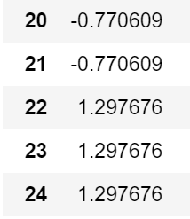point to keep in mind is the fact that the target has also been scaled (see Figure 11) and to be considered as data that is dichotomous, meaning that it represents two possible outcomes.

Figure Targets after scaling.

In effect, these values are now treated as if they were continuous and can use a special case of the Pearson r correlation coefficient call Point-Biserial correlation where the diagnosis can now be compared against the other features to determine their relationship(Calkins, 2005). In other words, one can look at whether a feature relates more to a malignant or benign diagnosis.

# 6. Exploration and Feature Selection using Visualisation

The goal of this task is to do **feature selection**. In the context of machine learning is to find the most suitable features to train the algorithm with. The reason for selecting only a subset of features is to avoid underfitting or overfitting.

**Underfitting** is where bias occurs because an algorithm has not been provided with a suitable number of relevant features, therefore missing any statistically important ways of making predictions across different dimensions that might be statistically relevant. For example, an instance of cancer may be defined as malignant by two or more features, but these features can’t predict malignancy individually or maybe malignancy can be defined by more than one feature or different dimensions. Underfitting normally occurs when there are not enough features(Géron, 2017, pp. 28–29).

**Overfitting** happens because an algorithm considers irrelevant or redundant noise, creating high accuracy scores but ultimately being useless for any practical application as it breaks the model’s generalisation capabilities for any new data point that may be presented. In other words, the boundaries of the model may go into unnecessary detail about a minor few instances during the training creating the possibility for a new instance to be misclassified should it fall into a zone where this noise in the data occurred during training. Overfitting can occur when too many features have been selected(Géron, 2017, pp. 26–27).

Both these issues can be solved by careful choice of features, gathering more data (in this case there was no way to find more) and reduce noise by using feature engineering methods such as PCA(Pierson, 2017).

Moreover, finding the optimal features can improve efficiency and performance of the model when training as the algorithm has less input to process which can be useful for larger projects. Another reason is that it makes the model simpler to interpret for scientists and researchers(James et al., 2013, p. 204).

To find these optimal features various visualisation techniques have been employed to allow for an easy and in-depth way to look at the data at a more human level. Some other methods include some automatic feature selection of which includes **Iterative Feature Selection** where machine learning can automatically rank feature importance, this is called recursive feature elimination, though this method can obscure genuine analysis understanding of the data(Müller, 2016, pp. 242–243).

## 6.1 Subplots and Histograms

It is handy to create views of the data side by side for better comparisons. This is where the concept of subplots come in useful. Matplotlib provides a useful method to do this within a single figure. Various structures can be created such as grids or inset plots(Vanderplas, J. T., 2016, pp. 262–268).

The initial task looked at the distribution of each feature and if the distribution shape indicated that the feature makes for a good classifier. This was done by taking each feature and then creating a set of subplots histograms for each feature where the features are placed into 50 bins and then colour coding them into blue and red to distinguish which bin contains malignant or benign points (see Figure 12).

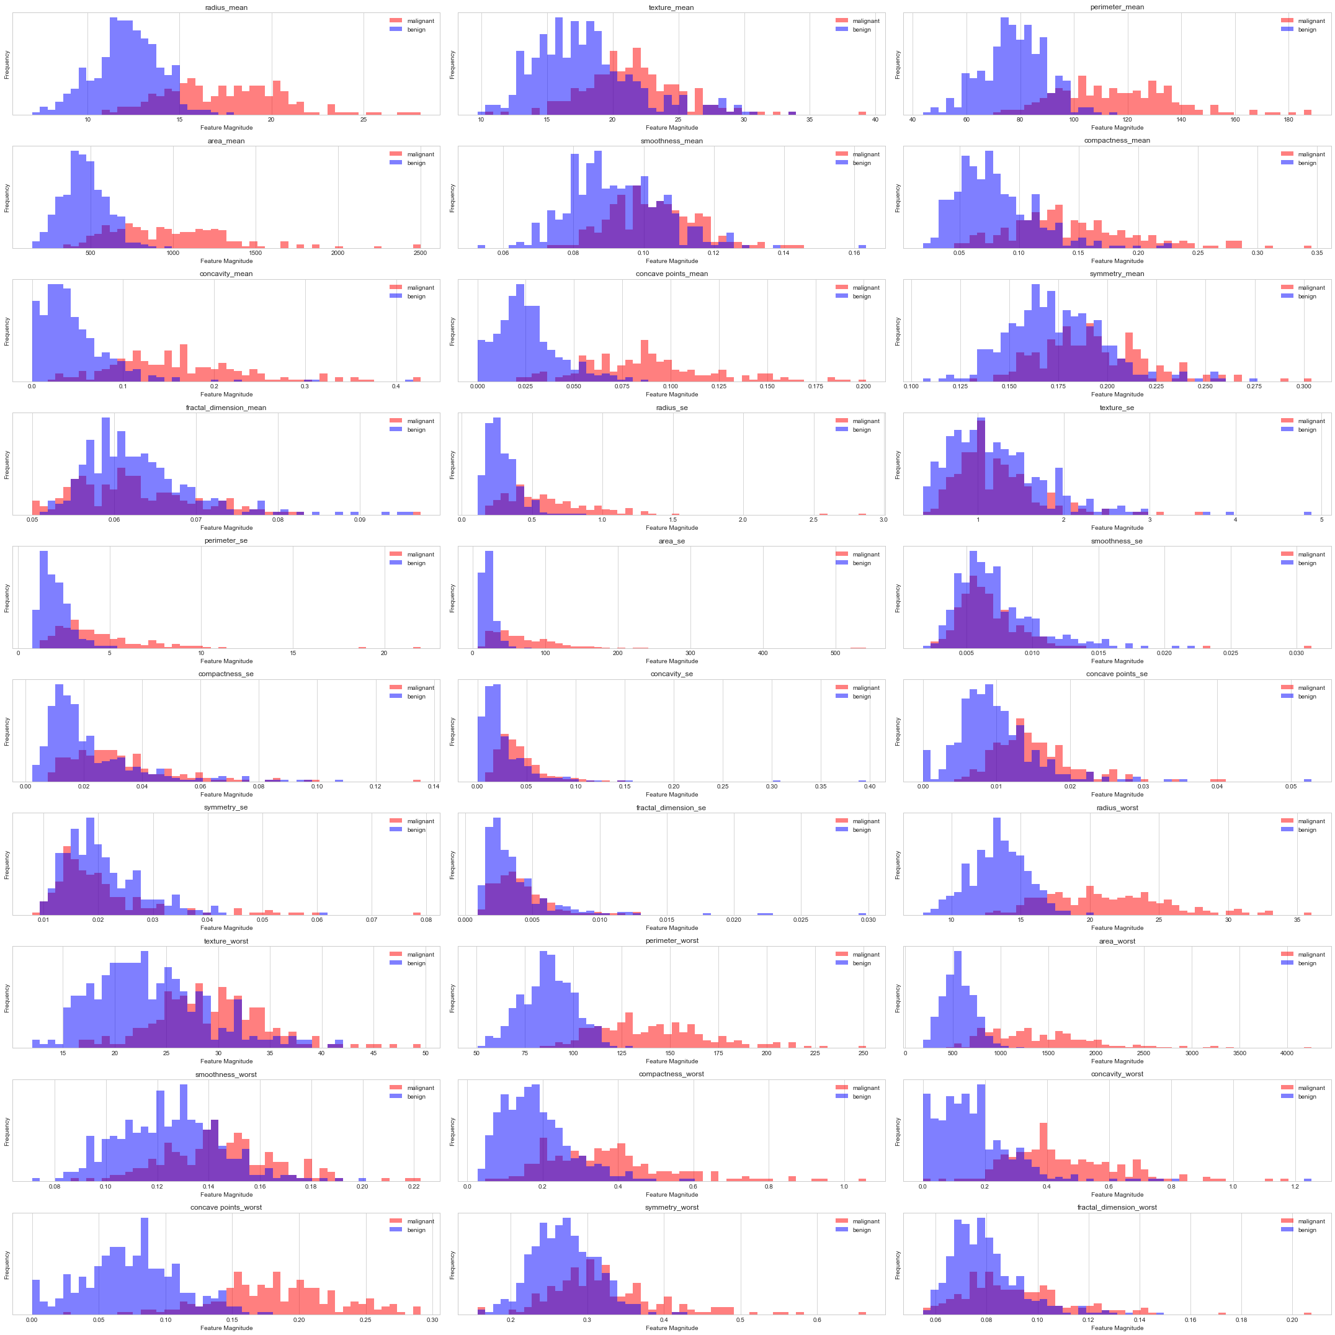

Figure Histogram subplots of the distribution for each feature. Each feature is coloured to show the interaction between the distribution of the feature and class.

As can be seen, there are quite a few features that have distinctive distributions spread far from where benign instances typically lay such as ‘**concave worst_points**’ (1,1). This makes sense because as mentioned in the data understanding, features that have higher values are considered more likely to be malignant. Though, this is not always the case, as can be seen in certain features such as ‘**fractal_dimensional_mean**’ (1,7) where there are some instances that are still malignant but not that far dispersed meaning that this still might provide some useful classification value for some rare data points though one must not overfit as mentioned. As well as that, there is a lot of overlap of each class for a lot of features.

This method of using subplots can be useful when a dataset contains a lot of features. One other common method is to use a scatter plot (example in Figure 12) matrix to deduce information on the feature class relations as well as correlations between features but because this dataset has 30 features. This would have been unwieldy to look at $420 = (30 * 14)$ individual plots and hard to visually interpret because they would be too small(Fox, 2016).

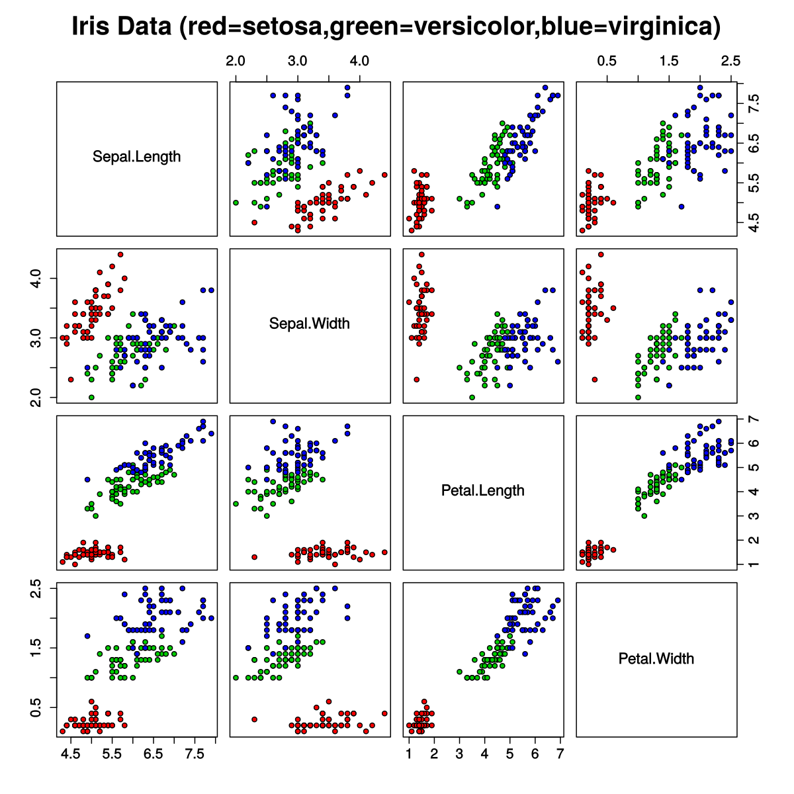

Figure This is a scatter matrix of a famous dataset about iris flowers(Wikipedia, 2018a). As seen, it does not contain nearly as many features as the cancer dataset, so this plot becomes quite appealing to use for feature exploration in this case.

One of this issues of using the subplot method is that does not provide much insight to into the relations between features. So further exploration was needed to reduce the amount of predicting features in preparation for the algorithm training.

## 6.2 Dimensionality Reduction using Principle Component Analysis

PCA is an unsupervised machine learning method used for dimension reduction. It is frequently used in many ways including;

* Image Analysis
* Compression
* Data Reduction
* Visualisation
* Noise Elimination
* Feature Extraction

It creates linear combinations of features, producing principle components. How this is done is by taking the data and creating orthogonal variants of multiple features compressed into a principal component. These new components lay between the original features, representing a combination of the original feature information, hence the term dimension reduction. You could imagine two features that are highly correlated could in effect be represented by a single feature since they contain the same underlying information with reduced noise. These principle components are represented by eigenvectors used to show the new feature space, to which to original data points are projected onto(Géron, 2017, pp. 211–215; Janert, 2011, pp. 327–349)(see Figure 14).

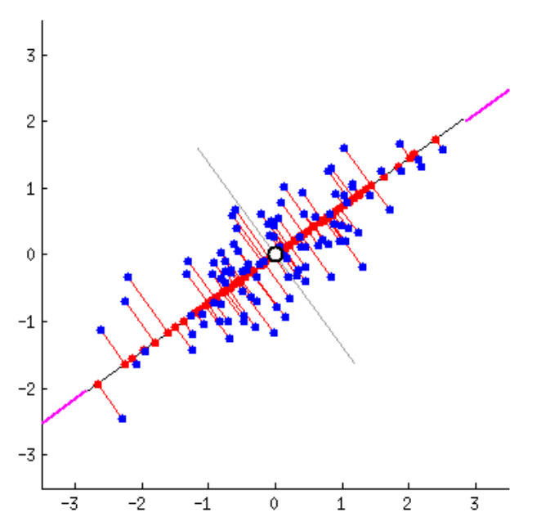

Figure A visualisation of how a principal component is produced. The two features are projected (red lines) in an orthogonal manner onto the first eigenvector or principal component (black line). The red dots are the combination of the original features(amoeba, 2015).

The reason for using PCA is that it is one of the most widely used methods for multivariate analysis(Janert, 2011, p. 328; Raschka, n.d.). With PCA, there are a lot of visualisation techniques that can provide detailed insight into the relations of the features.

## 6.3 Building the Principle Components

Scikit-Learn incorporates PCA functionality. PCA was employed using the following code;

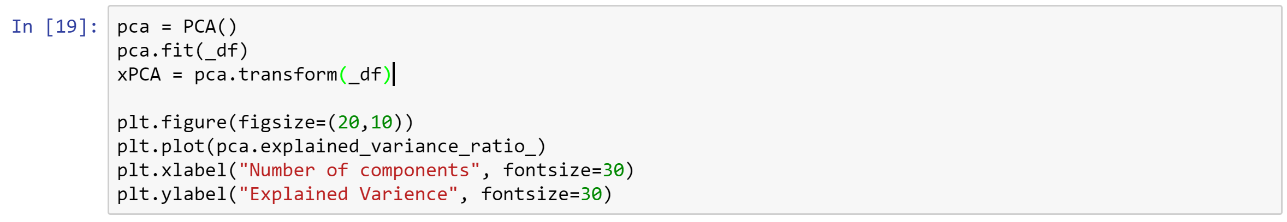

After building a new PCA object, the number of components should be reduced as to discard any noise within the data. This can be done with the assistance of a **scree plot** (seeFigure 15**)** and the elbow technique where the cut-off point should be where the line on the plot ‘elbows’.

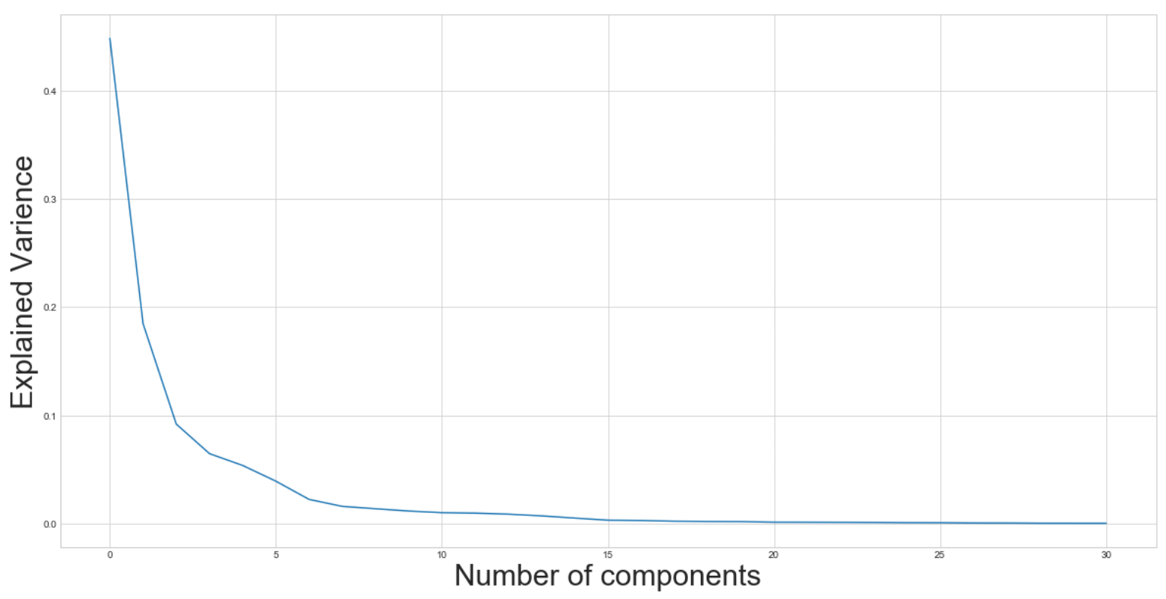

Figure This scree plot shows the drop-off in explained variance for each component. As can be seen, the elbow is at around 3 principle components which explain about 70% of the relevant information in this dataset.

As well as this, following a rule of thumb saying that at least 70% of the original information or explained variance should be kept(Pierson, 2017). This can be verified by specifying the number of components that should be returned from the PCA. In this case it the scree plot says that the optimal number of components is 3. This can be specified by the function as done by the following code;

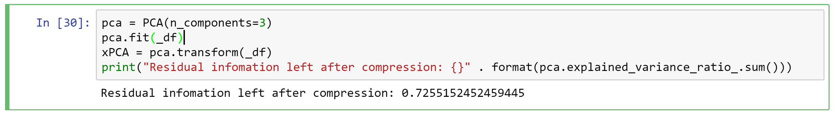

The residual information is around 72% which validates the assessment of the scree plot.

## 6.4 Analysing the Principle Components

The next tasks access these new components using various visual techniques. Because 3 components have been created, it is effectively a 3D cube of data. It is important to take this into account as there might be some useful information that can only be found in a multidimensional analysis(Janert, 2011, p. 330).

### 6.4.1 Correlation Heatmaps with Principle Components

The second exploration technique used was a correlation heat map. In this, the function takes in the components as well as the original features and find the Pearson r values using the following;

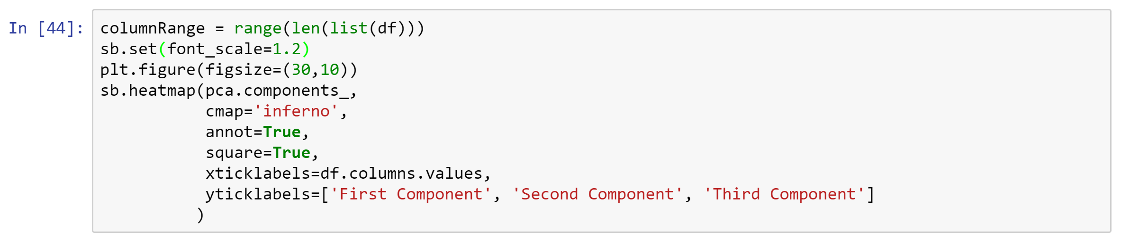

This produces a clear way of looking at how features are correlated to one another in a detailed way. In this visualisation, diagnosis is most strongly correlated with the first component and negligibly negatively with the second and third. Seeing this means that any feature that has a high correlation in with the first component has a good chance of being a strong predictor for diagnosis.

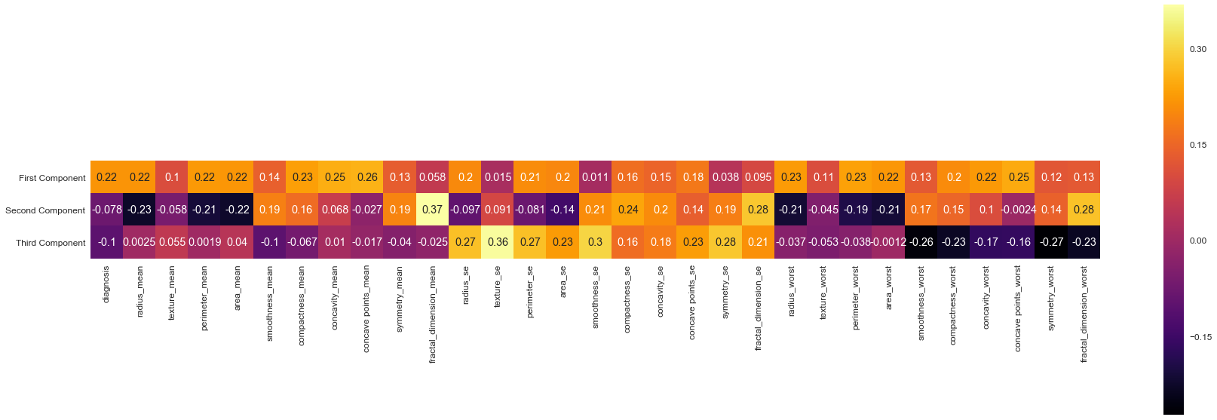

Figure Correlation heatmap of the principal components and the original features. The brighter the colour the stronger the correlation between the components.

Further interpretation shows that this data is prone to overfitting, being that this dataset has multiple features that are good at predicting and outcome but may clash to produce instability when presented with a new instance unless the number of input features is reduced to improve generalization. Another word for this is situation multicollinearity, where features have very similar underlying information(Wikipedia, 2018b).

### 6.4.2 Score Plot of the Principal Components

To further understand the relations of the feature a Score plot was employed to assess the spread of the data points. The score plot is a simple scatter plot that specifically looks at the Principal Components. For the implementation the following code was used;

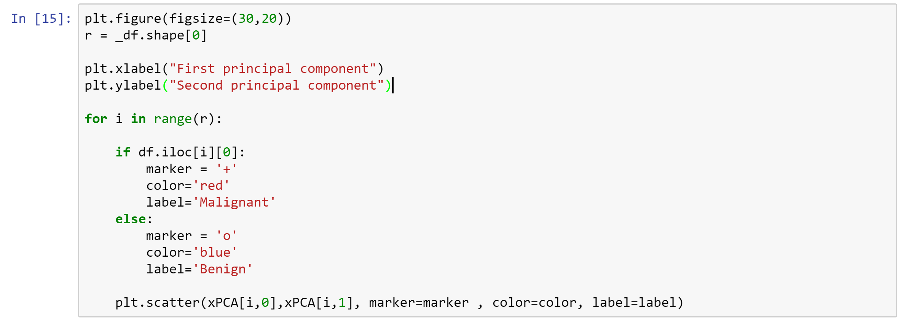

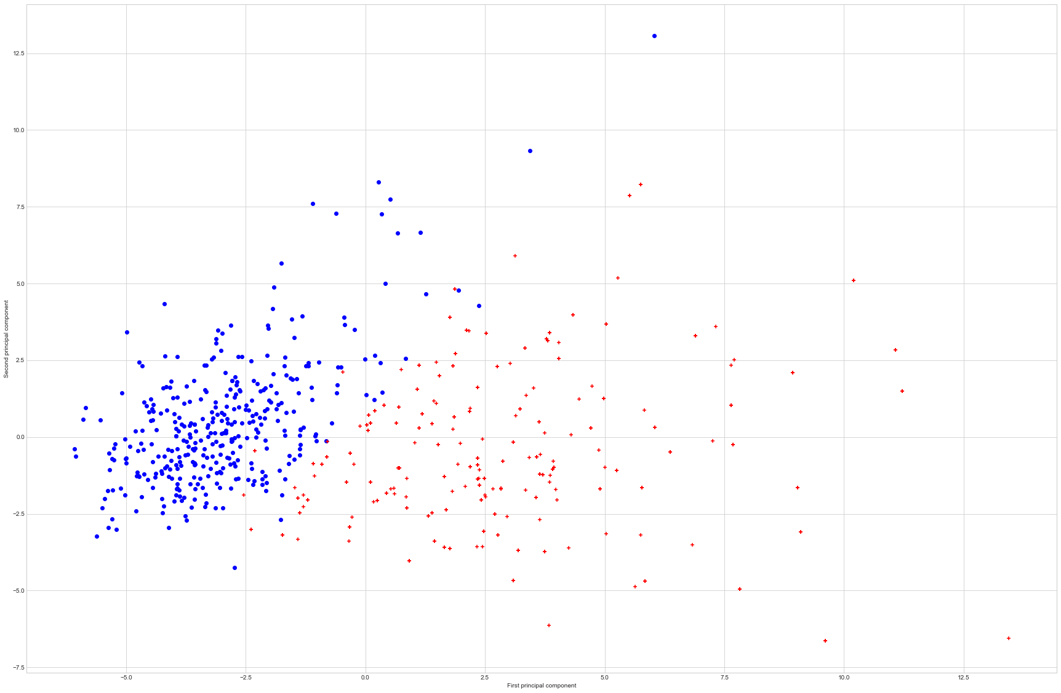

Figure This score plot shows the difference between the two classes, red being malignant. As can be seen malignant point generally are more dispersed than benign instances. Some malignant points that overlap into the benign points.

Interpreting this shows that there is a good distinction between the two classes. It shows very clearly that the higher the value along the first component (x-axis) the more likely it will be that the instance will be malignant, the same information that was deduced from the heat map analysis (Figure 16). Another point to note is this clearly shows that some data points will most likely be very difficult to identify as they are in close proximity to the opposing class, meaning that misclassification is inevitable for some instances which is a common occurrence in machine learning and other real-world data(Grimson, 2017). This is reflective of the subplot analysis at 6.1 earlier where features of the classes overlap each other.

### 6.4.3 Feature Relations Analysis Using a Biplot

Effectively, a Biplot is a combination of a Score Plot (as seen in 6.4.2) and a Loading Plot. What a loading plot does is it takes the vectors, also known as Loadings of the original features space and superimposes them over the score plot producing the Biplot(Janert, 2011, pp. 346–348; Minitab, n.d.).

Python and its libraries do not contain a Biplot function so one had to be built using Matplotlib. This was done by using values are stored inside the PCA object as components_. These values can be vectorised by calling .T on the component attribute(Rossum, 1995; n.d.). These vectors are then used to create a function to plot arrows for each original feature projection over the score plot. This is the code;

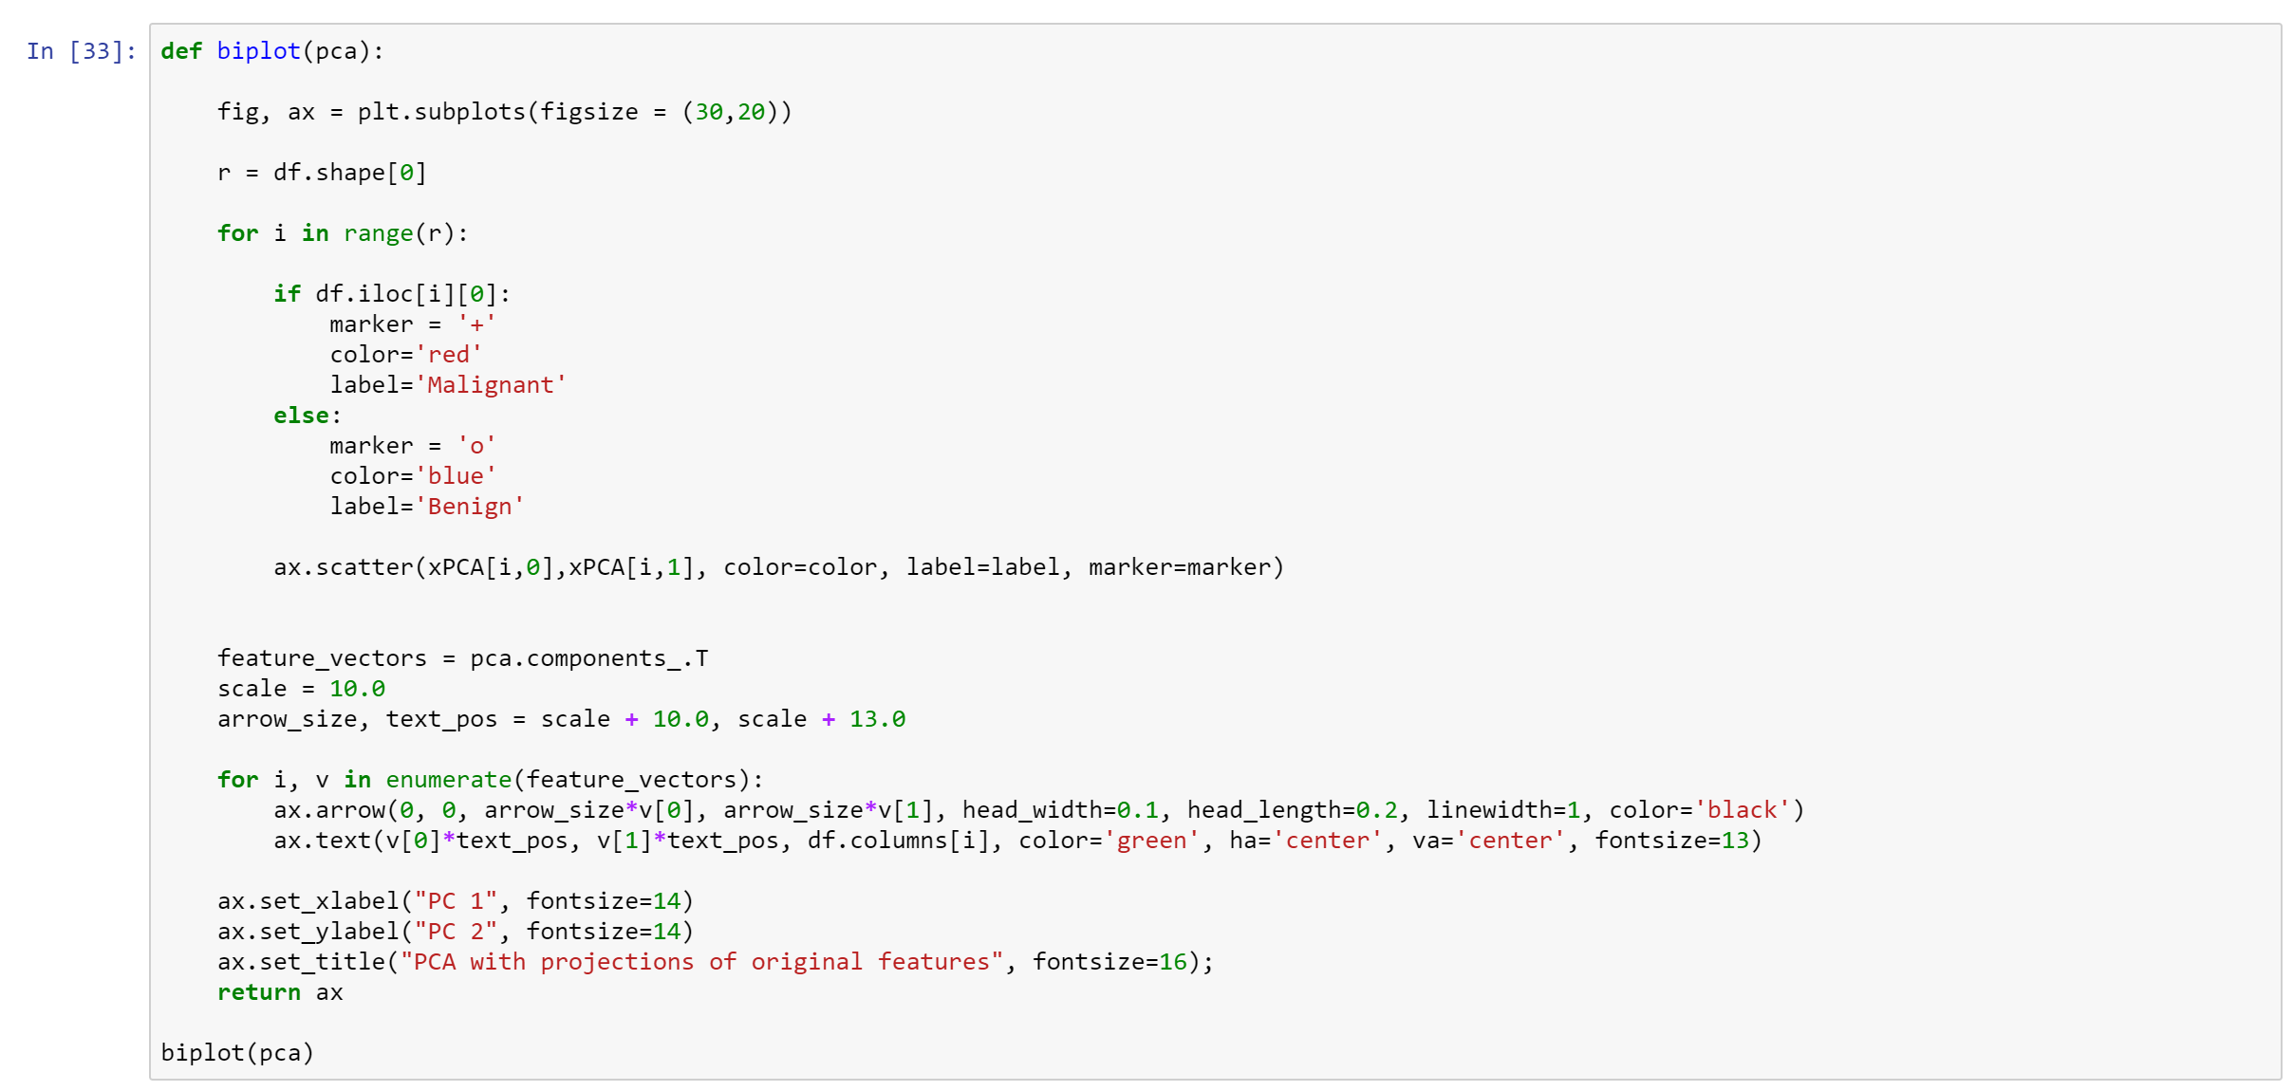

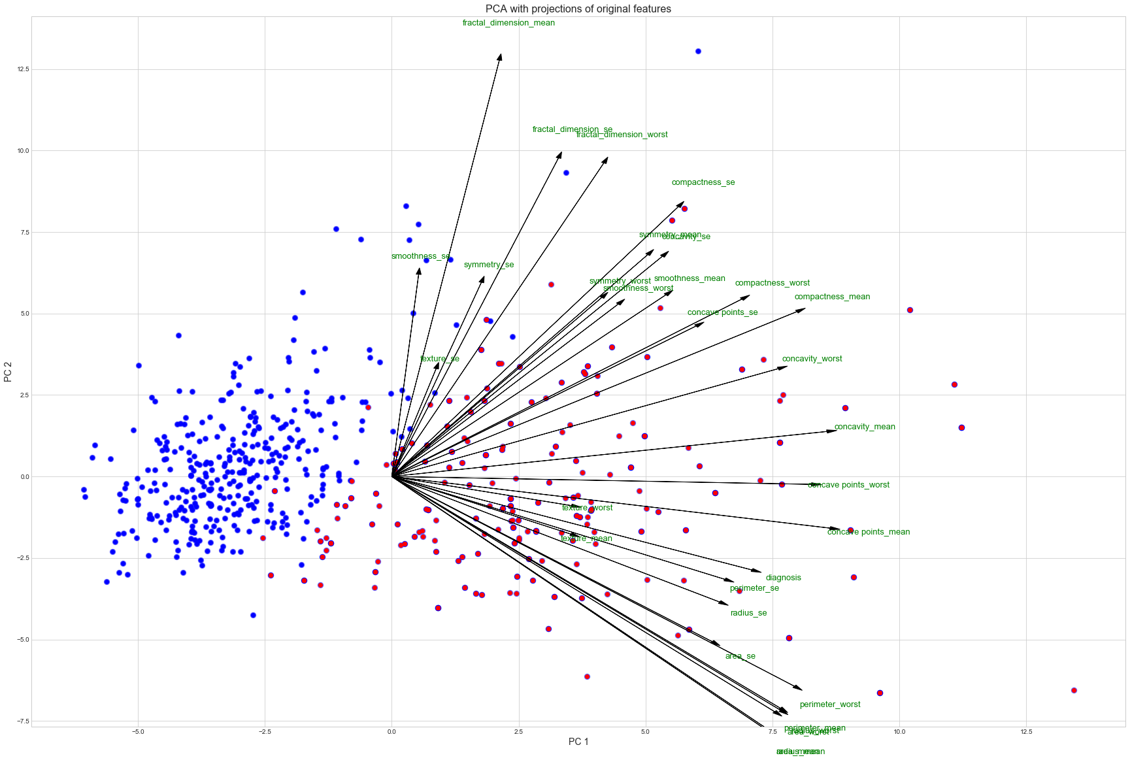

Figure This biplot shows the relations of each of the features superimposed over a scatter plot of the Principal Components of the dataset.

This shows a lot of information on how the features relate to one another. Interpreting this shows that most of the features are highly correlated with the first principle component as seen earlier with the heatmap but now it is easier to see the relations between specific attributes. For example, ‘perimeter_se’ is closely related to ‘diagnosis’ meaning that it is a strong predictor but ‘radius_se’ is also closely related, one of these could be considered redundant. To choose which one will depend on the Pearson R value of the heatmap earlier where the ‘perimeter_se’ score is .21 versus .2 for ‘radius_se’ making the latter less correlated to diagnosis ever so slightly. This analysis is repeated until the number of features has been reduced sizably.

As there are 3 Principal Components, different views of the data might provide insight into strong predictors along a different axis. This is a simple matter of selecting a different combination of the Principal Components I.e. choosing PC2 and PC3 to plot from a view from the front or PC1 and PC3 for a top view. This follows the idea of a multidimensional analysis mentioned earlier(Janert, 2011, p. 330).

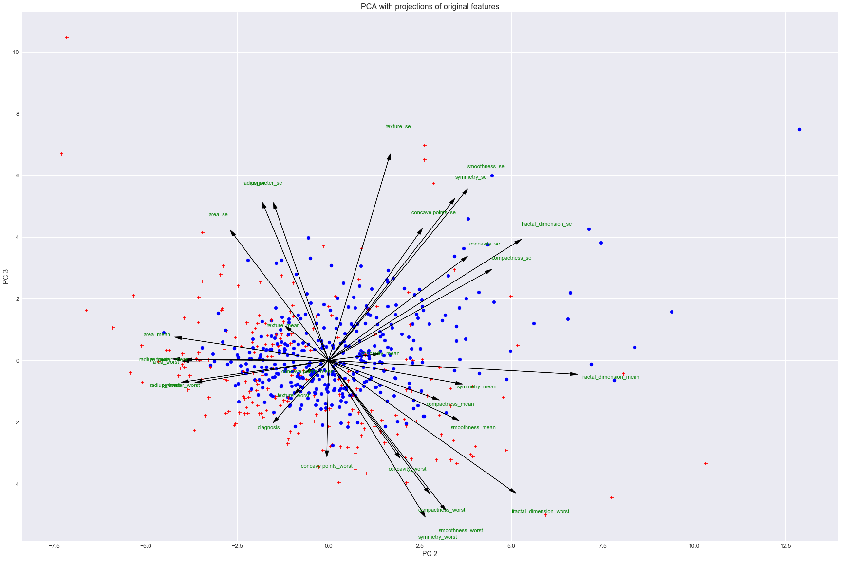

Figure Biplot of Principal Component 2 and 3. This could be considered a front on view of the data. This view has not got nearly as much separation of the classes but still yields some interesting information of feature effects and relations.

As done with the first Biplot, looking at the features in this show that ‘diagnosis’ opposes three features called ‘concave points_se’, ‘symmetry_se’ and ‘smoothness_se’. These about the heat map analysis shows that these points make some good predictors of some of the benign instances, being that they have a negative correlation with the positive diagnosis. This can be seen in the score plot underlying these features are in correlation with blue marks which are opposingly dispersed from ‘diagnosis’. This makes sense as looking back to the example in the data understanding, higher values of smoothness and symmetry are attributes of a benign growth. This was not as easy to deduce from the first biplot.

## 6.5 Supplementary Heatmaps plots for feature Correlation analysis

A **correlation heat map** of every feature against each other (Janert, 2011)(see Figure 20). This helps feature selection, as it provides a Pearson r for all possible feature correlations as opposed to the PCA heatmap seen earlier (6.4.1) though was not heavily depended on.

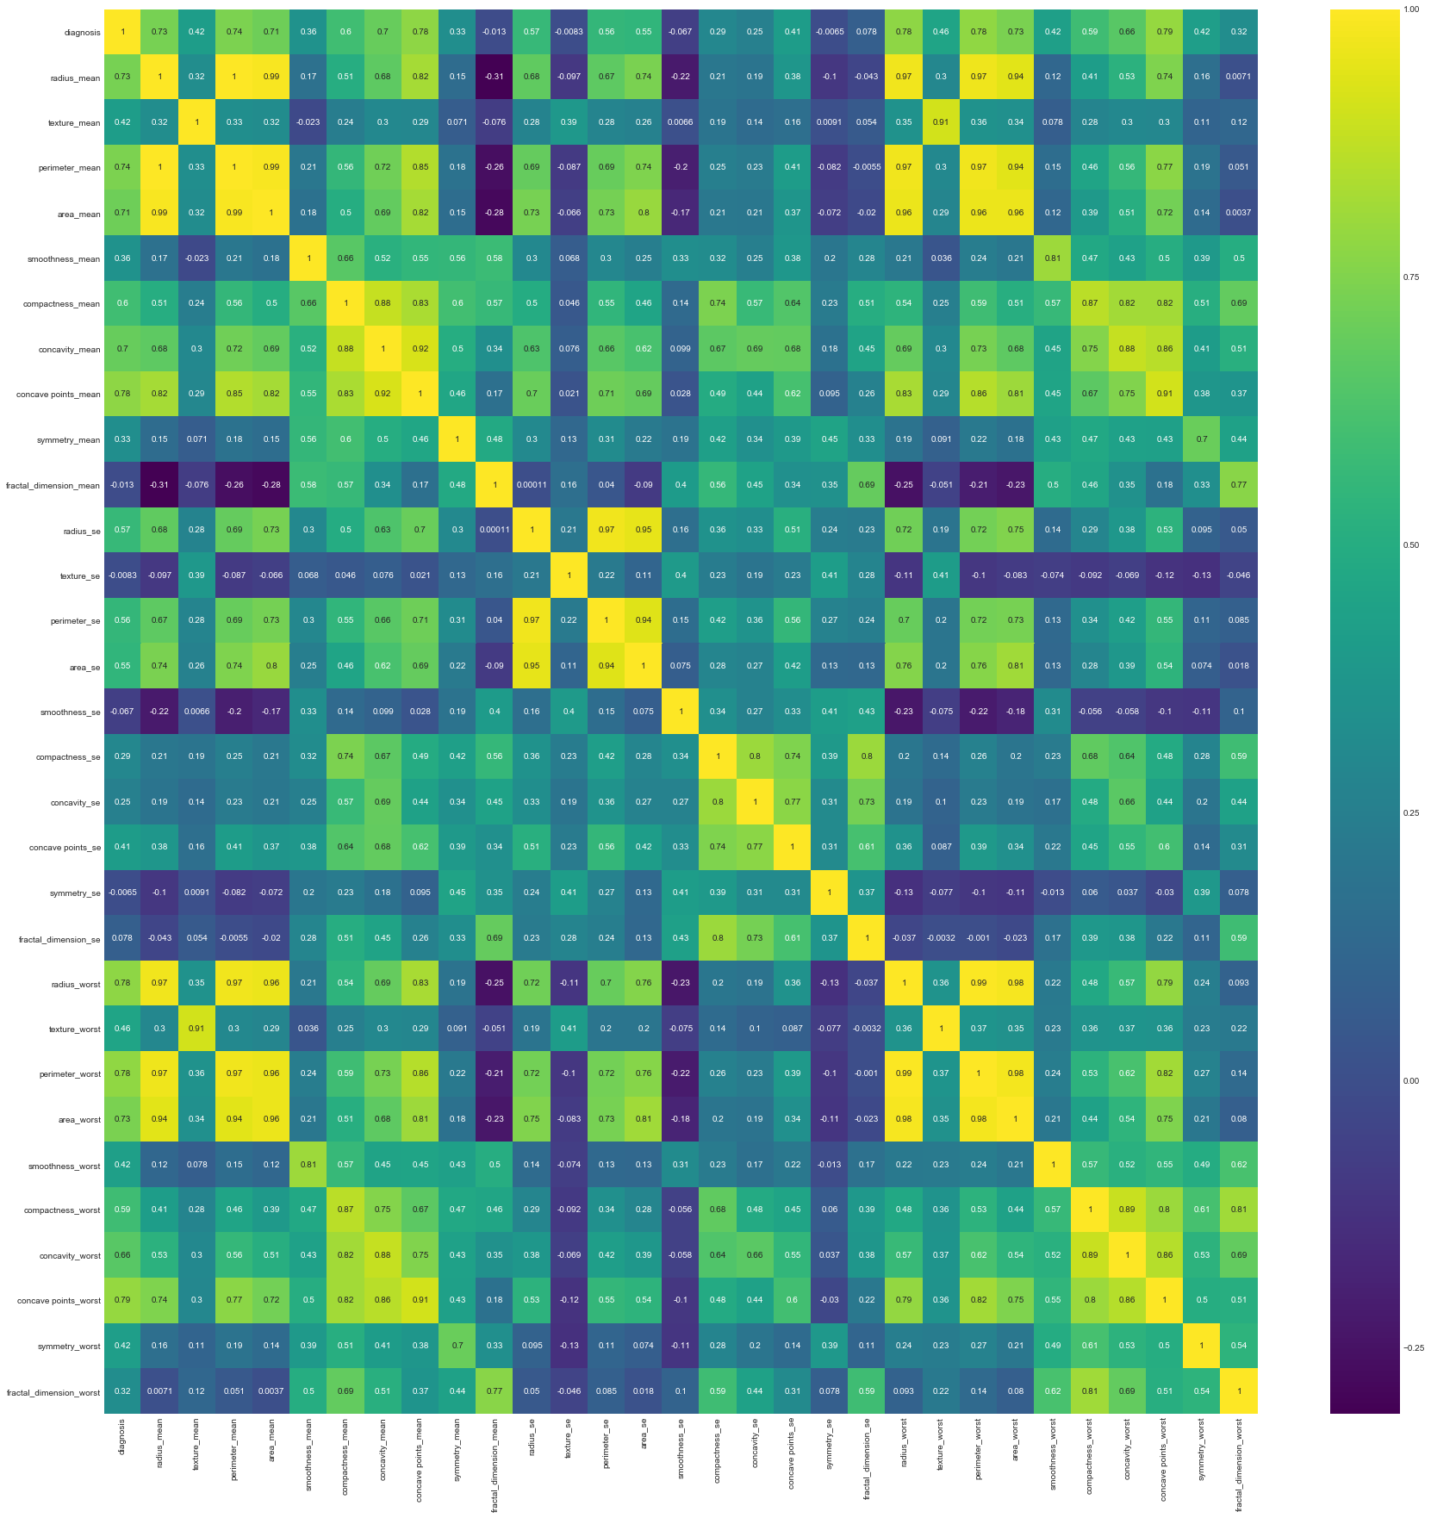

Figure Heatmap plot that shows the correlation of each feature in this dataset. This lighter the colour, the higher the correlation.

## 6.6 The Final Selected Features

Concluding the iterative analysis by interpreting these visuals, it was found that the features seemed to be the best predictors were **'perimeter_se', 'radius_mean', 'concave points_worst', 'texture_worst', 'symmetry_se'** as seen in the following section.

# 7. Training and Testing of Performance Metrics Results

The first step is to see what algorithm would be most suitable to apply to this problem. It was found that an ensemble classifier, specifically the **Random Forest Classifier(RF-C)** was the most appropriate choice. The reason for the choice is that as it is an ensemble algorithm, it runs as a meta-classifier that uses various different underlying decision tree algorithms such as Naive Bayes, Support Vector Machine(SVM) and Decision Tree(the one Scikit-Learn employs) on subsamples of the dataset then takes a vote on what the best probable class is looking at the mode classification of all the individual trees(Ho, 1995). In effect, it tries to find out what different algorithms say about the classification for some data and then looks at what the majority outputs are and that’s how it makes the best decision. Because of this, overfitting is less of an issue as variance or noise in the data is reduced and accounted for.

Some disadvantages of the random forest algorithm are that it can be performance intensive as the algorithm is running prediction multiple *divide and conquer*(Ferreira Filho, 2017, pp. 49–55) trees that can end up taking a lot of system resources and time to pass new data into the model but this is not a problem in this case as the amount of data in this data way below what the recommended limits of number of samples and features. Because of this, it was possible to set the number of estimators(trees) with some flexibility, to boost performance. This number was increased to 50 to the point where performance gains were negligible from any more trees(Ramon, 2014).

Next, within machine learning and binary classification problems, there are several methods of assessing the performance of a newly trained model. Typical practise is to split the data set into a training and test set with a ratio of normally 70% for training and 30% for the testing to run through the model. The test set gives an idea of the performance when the model is faced with new data as this is data that has not been seen by the model yet. The next step is to select the correct performance metric for the task. This choice depends a lot on the requirements of the system(Géron, 2017, p. 82; Müller, 2016, pp. 277–278). As mentioned in the business understanding (1.2), the model must be accurate and attempt to classify all instances that are potentially malignant to support a clinical decision. In other words, the importance of classifying benign points is not important compared to capturing potential risks so misclassification of benign points is not as much of a concern.

## 7.1 Accuracy Metric and its Flaws

**Accuracy** is a common method of measuring performance. This represents how many points overall have been correctly classified and is represented as a percentage. How this is calculated is by taking the total amount of True Positives(TP) i.e. the amount of correctly classified malignant instances, and True Negatives(TN) i.e. the amount of correctly classified benign points then dividing by the total population represented as $ACC = (TN+TP)/(P+N)$. This metric however, falls short when trying to analyse the performance of imbalanced datasets as per mentioned in the Data understanding section about the Accuracy Paradox (see 4.3). Because of this, it is recommended that different metrics and methods are used(Brownlee, 2015; Géron, 2017, pp. 83–84; Grimson, 2017; Müller, 2016, pp. 278–279).

## 7.2 Solutions to the Accuracy Paradox

### 7.2.1 Resampling the Data

One method of addressing the imbalanced dataset is resampling to balance out the data making the accuracy metric more relevant(Brownlee, 2015). Two ways are using the resample utilities in Scikit-Learn. This is done by either **upsampling** (see Figure 22) the minority class by duplicating random instances to match the majority class count or **downsampling** the majority class to match the minority class count(Fawcett, 2016).

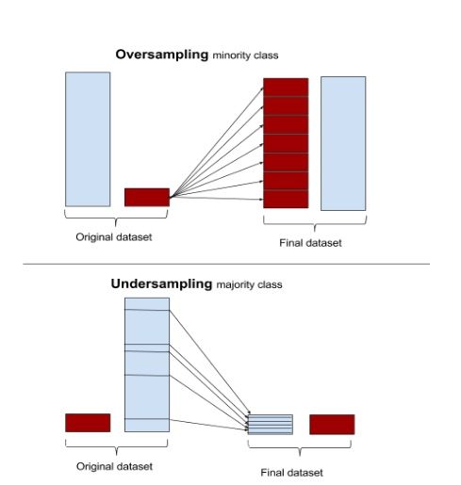

Figure The results of doing a resample, either up or down(Fawcett, 2016).

Some issues with upsampling can make the data unrepresentative of the real world as upsampling can infer that the class has a lower variance thus making a worse generalization capability and for downsampling, the inverse can happen(Roe, 2012).

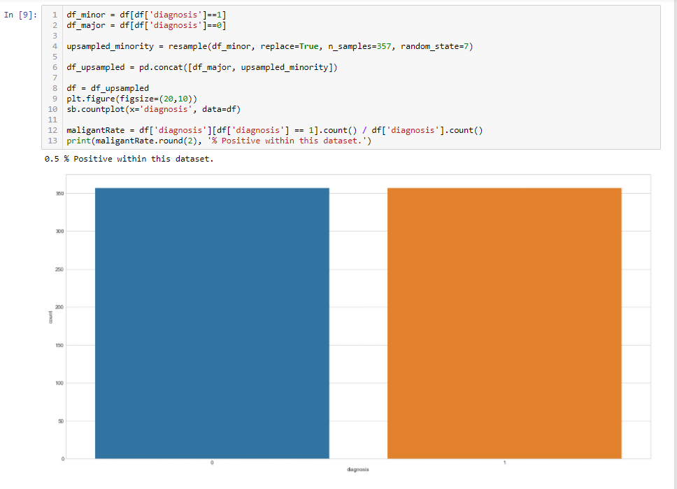

Figure An example of upsampling using python. The plot shows that the dataset as now balanced.

A third method is to use **Synthetic Minority Over-sampling Technique** (SMOTE) which generates synthetic data points based on the already existing data(Chawla et al., 2002). It is assumed that the ratio of the classes is representative of the true frequency when collecting the data thus should be considered by looking at raw unmodified data(Guttag, 2016b).

### 7.2.2 Using Precision and Recall Metrics

A common option is to look at performance for each class individually. This is done by looking at what is known **precision and recall** where precision is the measurement that out of all positive instances, how many did the model successfully predict, mathematically represented by $TP / (TP+FP)$ and recall being out of all positive classified instances, how many are truly positive and not misclassifications of False Negatives represented by $TP / (TP+FN)$. This method helps to meet the business requirements as there is now a specific measurement of accuracy(precision) within the positive classification(Géron, 2017, p. 85; Guttag, 2016a). More on precision and recall, the confusion matrix is a common method of looking at these metrics (see Figure 23). It is a 2x2 array showing TP and TN as well as FP and FN. This can be retrieved by using the **confusion_matrix()** function from the Scikit-Learn library. The returned array is then visualised by passing it into the heatmap plot in Seaborn.

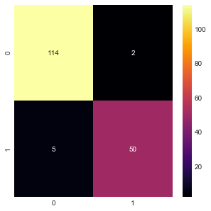

Figure The confusion matrix results showing that out of the test, a successful 50 out of 55 malignant points have been correctly classified and 114 out of 116 benign points have also been correctly classified.

## 7.3 Cross-Validation of the Performance Using Stratified Kfolds

To get an even better representation of the performance, it is recommended that a cross-validation method is used to get more accurate metrics based on the complete dataset. This means repeatedly training and testing a model over subsets of the full dataset then getting the mean from results of each subset trained model. This means that the performance metrics are reflective of the entire dataset and not just 30% of the data as done earlier using the confusion matrix. These subsets are known as *splits* that are contained within a *fold* and the amount of folds and splits is typically 5 to 10 depending on what the user specifies, in this case, its 10 splits (the number is arbitrary)(Müller, 2016, pp. 254–258). The method of cross-validation was done using Scikit-Learn’s Stratified Kfold which is optimised to deal with subset bias. This issue arises when splitting the data using a normal Kfold, meaning that subsets may only contain or comprise of one class. What the stratified method does is assure that each class is represented fairly(to the best ability) in each fold(Kohavi, 1995). The code;

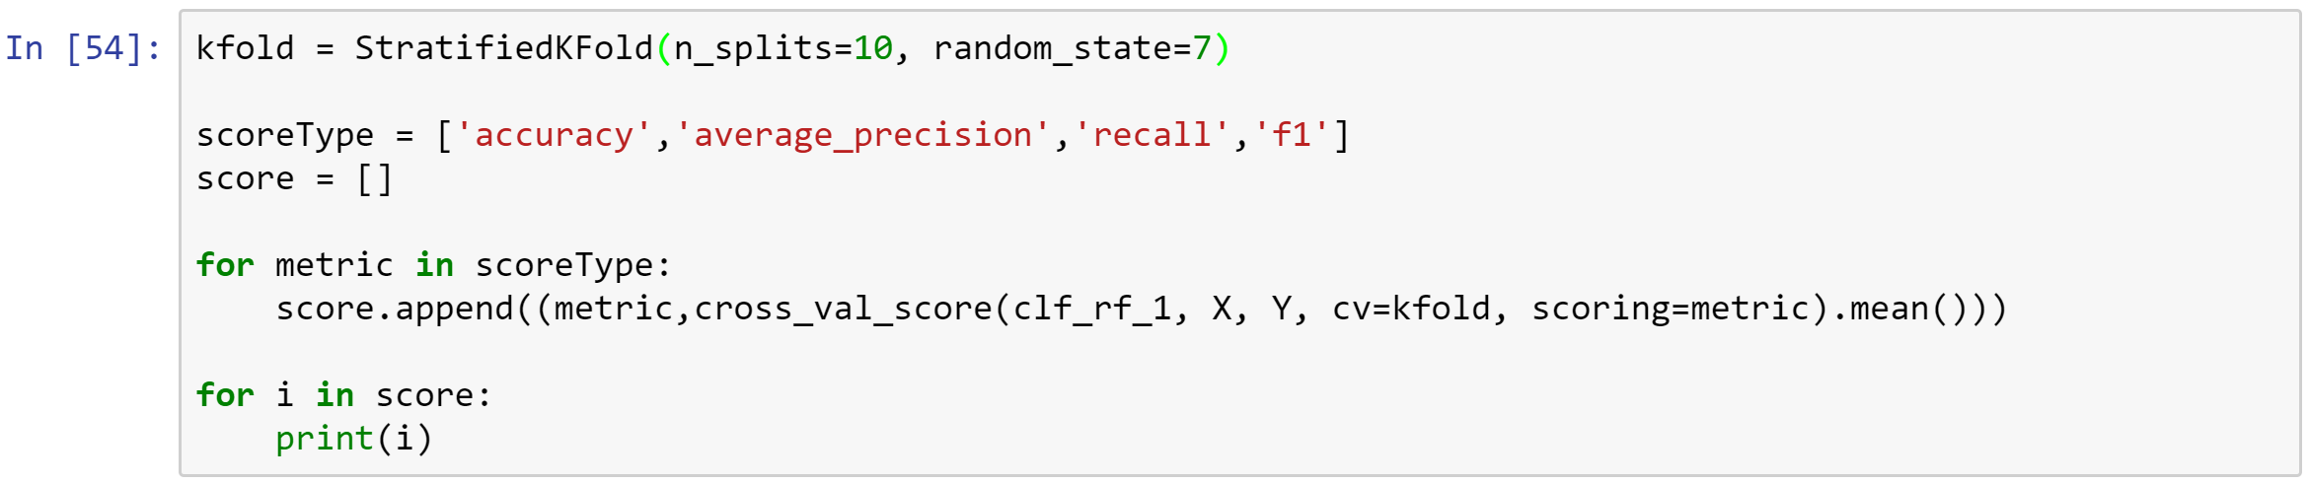

After running the cross-validation these results were achieved;

|  |  |  |
| --- | --- | --- |
| **Metric (Mean of CV results)** | **Score(Percentage)** | **Meaning** |
| Accuracy | 0.95099278368334628 | This score shows very high promise, though may not be truly reflective of the performance considering the data imbalance. |
| Precision | 0.98197953782261072 | A score like this is more than viable for a production system. Most of the malignant cases have been captured. |
| Recall | 0.91991341991342002 | High recall with only a small amount of benign accounts being classed as positive. These misclassifications are not as relevant to the success of the system. This score can be reduced in favour of a higher precision. |
| F1-Score | 0.9327524276014989 | Overall performance is strong. |

The last scoring metric is the **F1-score** which generalises precision and recall by finding the harmonic mean of the two which is a single measurement that addresses imbalanced datasets which is a better representation, making it a preferred metric compared to accuracy(Müller, 2016, pp. 286–288).

## 7.4 Fine Tuning Thresholds Using Receiver Operating Characteristic

And lastly, the **Receiver Operating Characteristic** (ROC) curve provides information on how to fine tune a model as well as showing the overall performance using ***area under curve***(AUC) as its score where the greater the area under the curve the better the performance(Hajian-Tilaki, 2013; Müller, 2016). Tuning is sometimes called adjusting the threshold or operating point (see Figure 24).

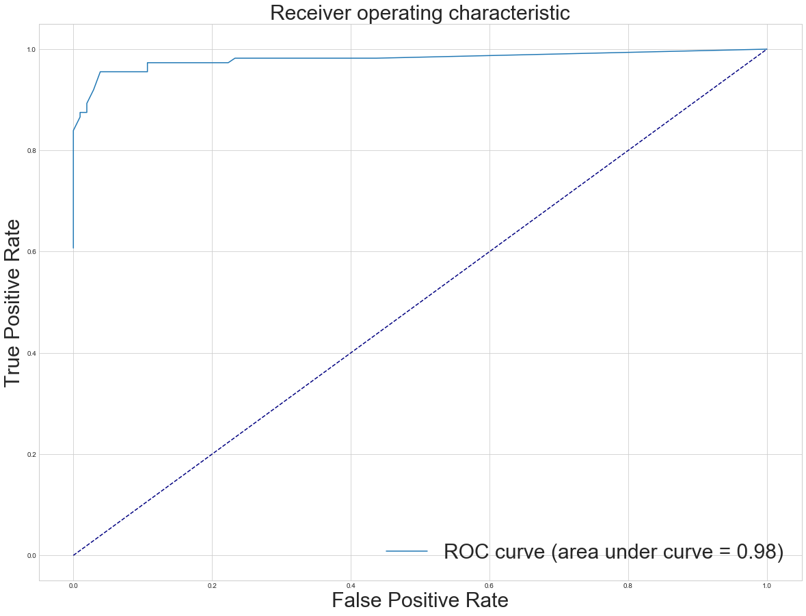

Figure Receiver Operating Characteristic. The figure shows that the performance of the model is strong but also shows a nice point where the threshold could be set to if wanting higher precision and a lower recall.

This is useful for adjusting the classification boundary in the model to make sure that malignant points are captured to minimise risk wherein figure 22 the optimal threshold is set at around 0.1 along X. By doing this, the model sacrifices its ability to identify benign points (low recall) by treating them as positive but will now have a better chance of capturing new instances of malignancy (high precision). It is important to understand that if the threshold is misidentified, then the model will become useless as it, for example, may identify too many benign data points as malignant which would not aid a medical practitioner in any way. A rule of thumb is again to look at where the line *elbows*(Berrizbeitia, 2016; Guttag, 2016a)*.* Moreover, the area under curve shows a very high score of approximately 98%. It can be safely concluded that performance is strong.

The full code block for the testing can be found in Appendix D under Testing.

# Evaluation

To access the system success, 5 participants were asked to look at the scores of the system performance and give a yes or no answer as to why they did or did not feel comfortable should they assessed by a computer model with the aid of a practitioner. They were then asked to further write a small justification for their answers. As well as this they were asked to participate in trying to deduce what features were the best predictors using the plots that were created for data exploration as to check the effectiveness or expert requirements to understand the plots. The full findings can be seen in Appendix B.

For the first topic, it was thematic of all participants that so long as a medical practitioner oversaw the diagnostic procedure, they would gladly welcome a CDSS. When asked after explaining the results meanings of the model testing they felt confident that the system would be accurate enough to be put into service given that the appropriate work is done to lift the system out of the initial analysis stage.

In the next evaluation, it was found that it took some extensive explanation of the plots as they are complex to interpret for people with limited training. Most answers were good after some understanding, but no combination of features deduced by the participants found to beat the analyst scores. It should be noted that a lot of the scores from the participants would still be statistically viable for a production system. Full detail of the scores can be found in Appendix B Figure 27.

# Future Work and Conclusions

The project has been successful up to the point of developing a prototype model that has statistical viability. The next steps would involve improving the model to perhaps collect and include more data as this is always a good idea. This could provide a more informative analysis that could reveal new features that are statistically relevant predictors along certain vectors when doing PCA analysis.

Moreover, this project only includes the stages of developing a model that would be implemented in a full CDSS. It would be productive and informative to develop an interface to make use of the example model. This would be in the form of some actual user interface that includes a form to take in new data points for it to produce a prediction as to whether this new patient needs further assessment or not. From doing this, more data can be collected and used to improve the model’s performance and dynamism. This would most likely be done in a low-level language to maximise efficiency that Python sacrifices for its high-level ease of use.

Doing this would also provide a means of assessing the patient and practitioner confidence in the system as this is one issue that has been mentioned in this document. Understanding these could give way to understanding the relationship between how human and the machine can be improved or not if the case may be. The confidence in a system like this seems to be strong judging by the response of the participants and the testing results, though it is to note that the participatory assessment is rudimentary at best as deploying the system would yield more real-world results. As well as this, seeing how actual practitioners would feel about using the artefact was not possible as obtaining their time was not possible. This is a crucial part of doing further work for understanding the success of the project.

Furthermore, improvements on the visualisations (section 6) could be used for any practitioner when trying to understand the characteristics of what growths poses a significant risk and understanding what this machine-learned model is doing. For instance, looking at some of the Biplots could be hard as some of the feature names overlap. This could be solved by reducing the feature projections down to the fundamental features that carry the most relevance in defining the data and diagnosis. Again, this could potentially improve confidence levels of the patient and practitioner. Moreover, understanding the data and what it represents could be further validated by working alongside some expert within the field of cancer research or a practitioner so improved plots would be helpful.

Extracting and abstracting some functions that had been created in Python would be useful should a similar analysis need to be done for a different project. One idea might be to work on making the Biplot function abstract so that it can take more variants of datasets. Adding better parameter inputs for better control of the plot output. This would be useful as this function does not exist within any Python plotting library as of the time this was written.

Lastly, the analysis techniques employed have been extremely useful in deducing how the data can be used to generate the machine learning model about the type of data contained within the set. PCA visualisations had the most useful initial insights to find out what features were most relevant but also seeing how the feature amount could be reduced as it showed where the correlations were happening in a more human interpretable way. The other plots such as the heatmaps and subplot histograms gave some indication but proved useful when assessed back and forth with the Biplots as they helped refine the feature selection by looking at the detailed Pearson R values and distributions.

# Reflection on Learning

The process of learning has been as thorough as possible as to not skip any potential detail, though as this is an early attempt at this kind of project, there were some issues that could have been better avoided about the process. For example, handling objects within Jupyter notebook such as the dataset’s DataFrame object had been done perhaps without much regard for how to store the various versions of the dataset after doing the various pre-processing steps. This leads to issues when trying to analyse the dataset after the data was balanced using upsampling. This manifested into some visuals not being representative of the data. This was eventually handled but proved a disruptive setback to the project. Solutions would be to make sure to keep all versions of the dataset before during and after data preparation in separate and carefully worded object names.

Furthermore, a better understanding of linear algebra, specifically the mathematical representation would most certainly help when trying to understand some of the concepts such as PCA. This would have provided a baseline knowledge to which learning would have happened quicker.

Some good points to note are that the speed at which the project unfolded was well within the expected time. Most of the targets and milestones were fairly on time. Learning about new topics was structured and time managed well overall. Effective resources had been found after much searching, talking to various people within the field and attending appropriate events such as lectures and talks. The Gantt chart in Appendix C gives an idea of how the project unfolded.

# Appendices

## Supporting Documents of Professional Approach

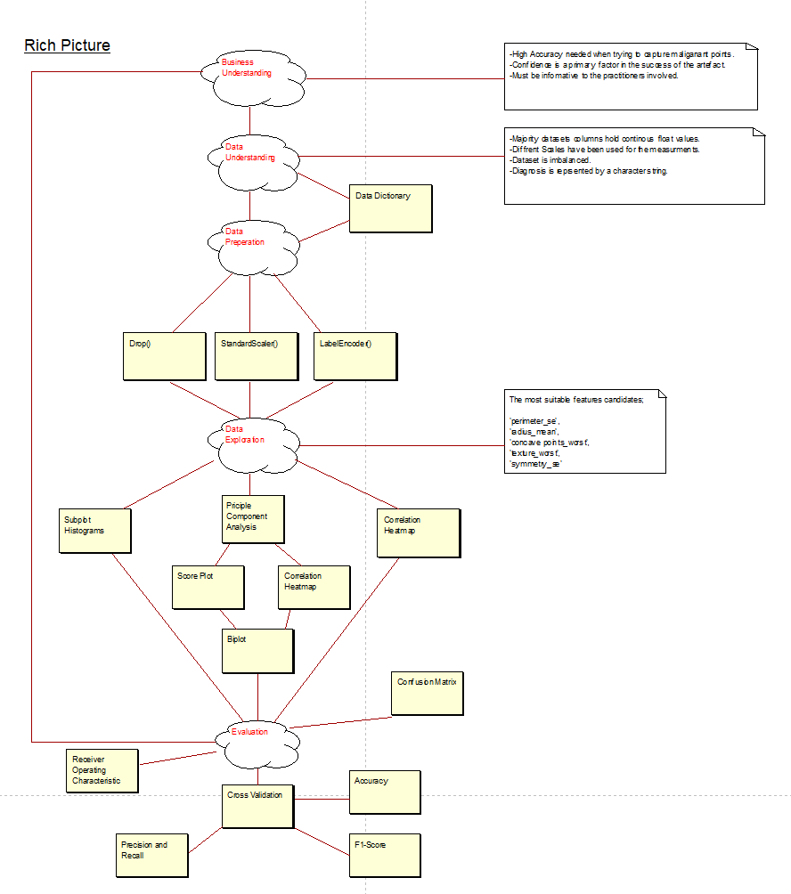

Figure Rich Picture of the artefacts during the process.

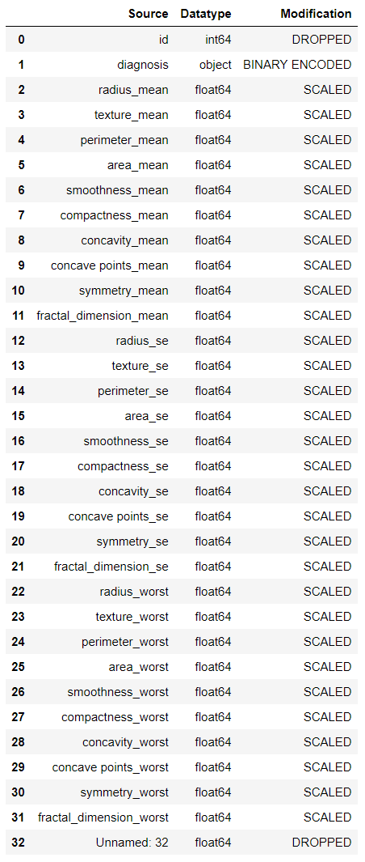

Figure Data Dictionary for the changes made to the dataset.

## Evaluation Results

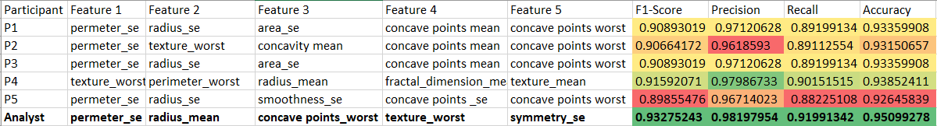

Figure Feature Selection Results Comparison.



Figure 28 Consent Form Anonymised

## Project Management

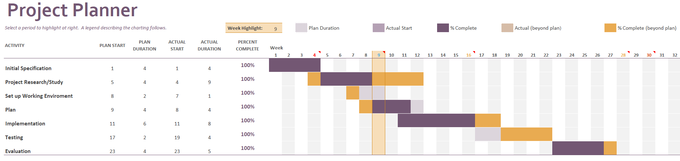

Figure Gantt Chart for the project timeline.

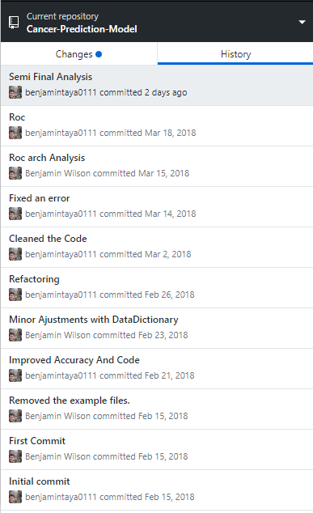

Figure History Log

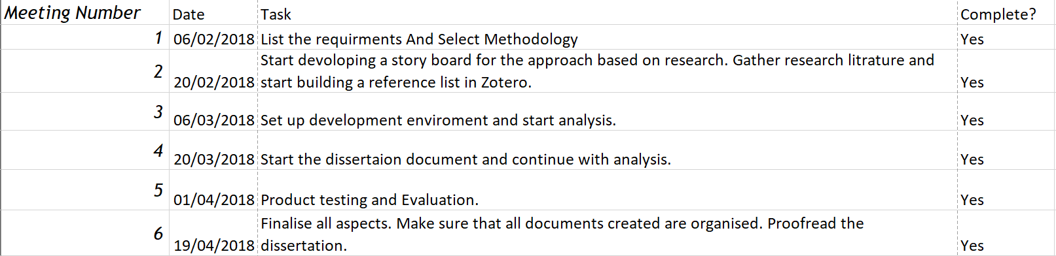

Figure Meeting Records Sheet

## Document Repositories and Code

GitHub Repository Link: <https://github.com/BenjaminIsaac0111/Cancer-Prediction-Model>

Data Source: https://archive.ics.uci.edu/ml/datasets/Breast+Cancer+Wisconsin+(Diagnostic)

### Project Set up and Data Dictionary

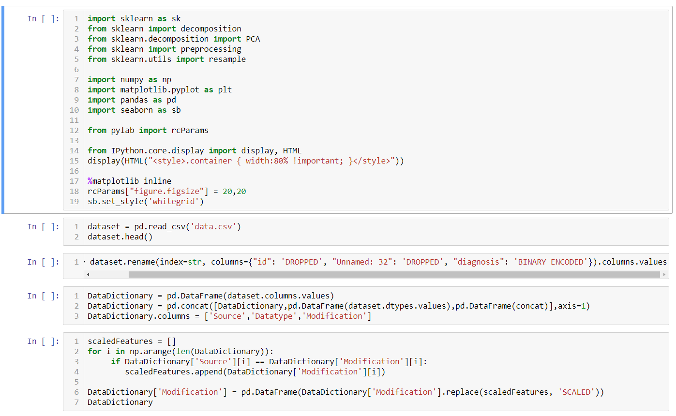

### Data Pre-processing and Preparation

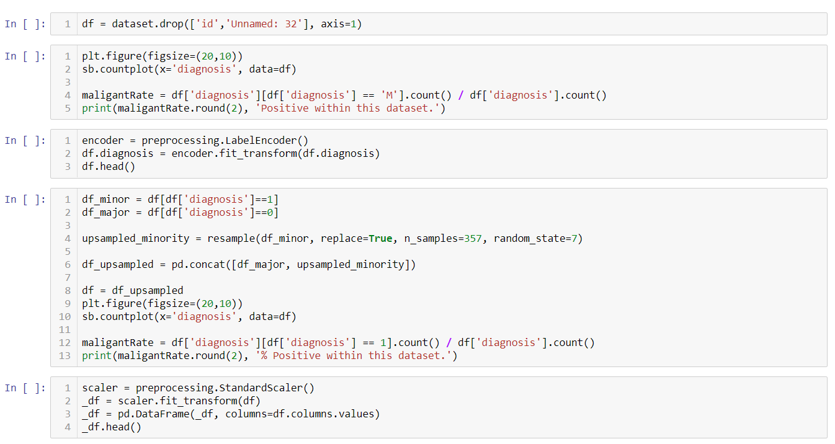

### Data Exploration and Visualisation

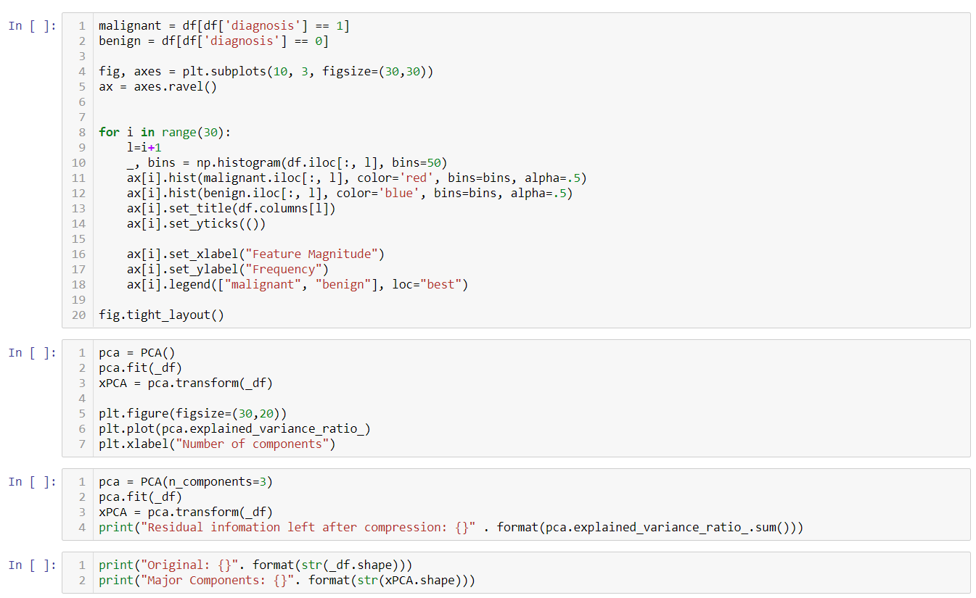



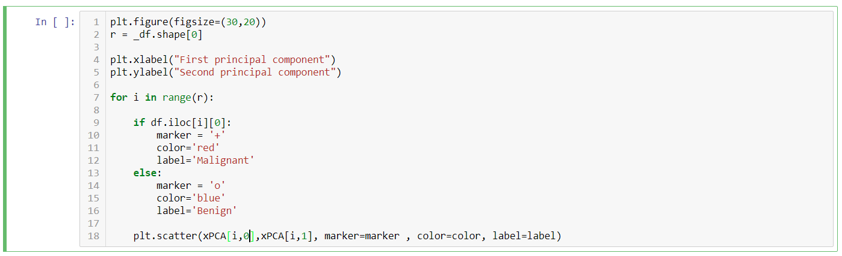

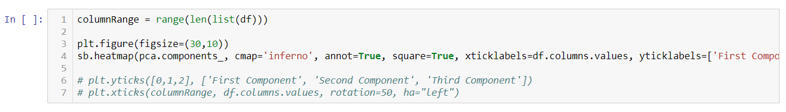

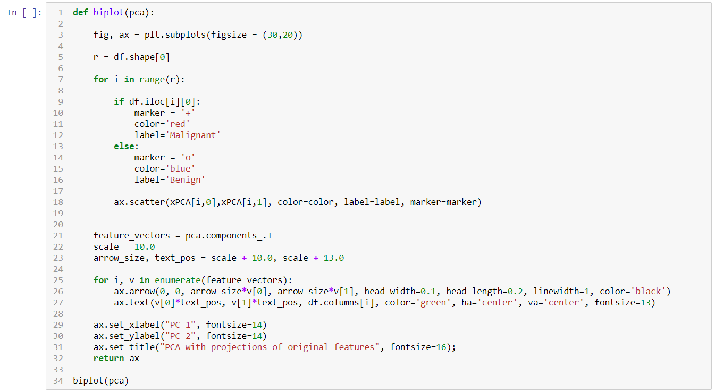

### Testing

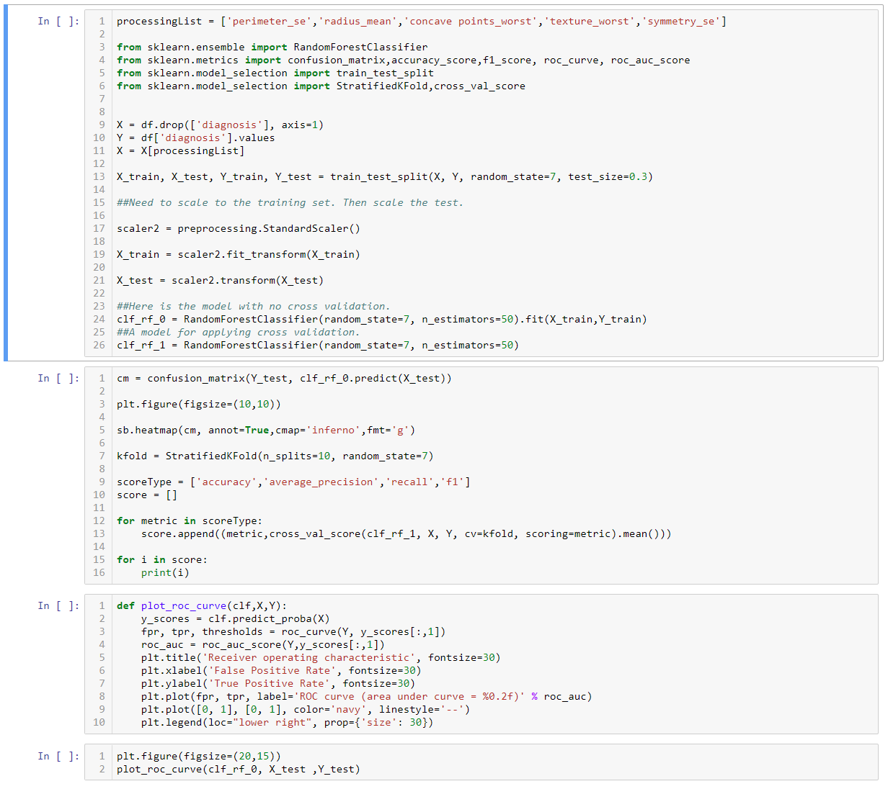

# References

Accuracy Paradox (2017a) , in: *Wikipedia* [Online]. Available from: <https://en.wikipedia.org/w/index.php?title=Accuracy_paradox&oldid=814373733> [Accessed 13 March 2018].

Akiwatkar, R. (2017) *The Most Popular Languages for Data Science - DZone Big Data* [Online]. dzone.com. Available from: <https://dzone.com/articles/which-are-the-popular-languages-for-data-science> [Accessed 21 March 2018].

Alexander (2017) *Python - Anaconda vs Miniconda - Stack Overflow* [Online]. Available from: <https://stackoverflow.com/questions/45421163/anaconda-vs-miniconda> [Accessed 21 March 2018].

amoeba (2015) *Pca - Making Sense of Principal Component Analysis, Eigenvectors & Eigenvalues - Cross Validated* [Online]. Available from: <https://stats.stackexchange.com/questions/2691/making-sense-of-principal-component-analysis-eigenvectors-eigenvalues> [Accessed 13 March 2018].

Anaconda (n.d.) *Downloads* [Online]. Anaconda. Available from: <https://www.anaconda.com/download/> [Accessed 21 March 2018].

Behnel, S., Bradshaw, R., Citro, C., Dalcin, L., Seljebotn, D. S. & Smith, K. (2011) Cython: The Best of Both Worlds. *Computing in Science and Engg.*, 13 (2) March, pp. 31–39.

Berrizbeitia, L. D. (2016) *Receiver Operating Characteristic (ROC) Curves* [Online]. Available from: <https://kennis-research.shinyapps.io/ROC-Curves/> [Accessed 16 April 2018].

Brownlee, J. (2015) 8 Tactics to Combat Imbalanced Classes in Your Machine Learning Dataset. *Machine Learning Mastery*, 19 August [Online blog]. Available from: <https://machinelearningmastery.com/tactics-to-combat-imbalanced-classes-in-your-machine-learning-dataset/> [Accessed 13 March 2018].

Buja, A., Swayne, D. F., Littman, M. L., Dean, N., Hofmann, H. & Chen, L. (2008) Data Visualization With Multidimensional Scaling. *Journal of Computational and Graphical Statistics*, 17 (2) June, pp. 444–472.

Calkins, K. G. (2005) *More Correlation Coeficients* [Online]. Available from: <https://www.andrews.edu/~calkins/math/edrm611/edrm13.htm#POINTB> [Accessed 31 March 2018].

Chawla, N. V., Bowyer, K. W., Hall, L. O. & Kegelmeyer, W. P. (2002) SMOTE: Synthetic Minority Over-Sampling Technique. June, p. 37.

Coiera, E. (2015) Clinical Decision Support and Analytics. In: *Guide To Health Infomatics*. CRC Press, pp. 417–472.

Cross-Industry Standard Process for Data Mining (2017b) , in: *Wikipedia* [Online]. Available from: <https://en.wikipedia.org/w/index.php?title=Cross-industry_standard_process_for_data_mining&oldid=807885507> [Accessed 2 April 2018].

Danielsson, P.-E. (1980) *Euclidean Distance Mapping*.

Dombal, F. T. de, Leaper, D. J., Staniland, J. R., McCann, A. P. & Horrocks, J. C. (1972) Computer-Aided Diagnosis of Acute Abdominal Pain. *British Medical Journal*, 2 (5804) April, pp. 9–13.

Fawcett, T. (2016) *Learning from Imbalanced Classes* [Online]. Silicon Valley Data Science. Available from: <https://svds.com/learning-imbalanced-classes/> [Accessed 15 April 2018].

Ferreira Filho, W. (2017) *Computer Science Distilled: Learn the Art of Solving Computational Problems*. Las Vegas, [Nevada: Code Energy LLC.

Fox, G. (2016) *The Matrix, It’s a Complex Plot | Minitab* [Online]. Available from: <http://blog.minitab.com/blog/data-analysis-and-quality-improvement-and-stuff/the-matrix-its-a-complex-plot> [Accessed 2 April 2018].

Géron, A. (2017) *Hands-on Machine Learning with Scikit-Learn and TensorFlow: Concepts, Tools, and Techniques to Build Intelligent Systems*. Beijing Boston Farnham Sebastopol Tokyo: O’Reilly.

GitHub (n.d.) *Build Software Better, Together* [Online]. GitHub. Available from: <https://github.com> [Accessed 19 April 2018].

Grimson, E. (2017) *11. Introduction to Machine Learning - YouTube* [Online]. Available from: <https://www.youtube.com/watch?v=h0e2HAPTGF4> [Accessed 10 April 2018].

Grus, J. (2015) *Data Science from Scratch: First Principles with Python*. Sebastopol, CA: O’Reilly.

Guttag, J. (2016a) *14. Classification and Statistical Sins - YouTube* [Online]. Available from: <https://www.youtube.com/watch?v=K2SC-WPdT6k&t=5s> [Accessed 15 March 2018].

Guttag, J. (2016b) *15. Statistical Sins and Wrap Up - YouTube* [Online]. Available from: <https://www.youtube.com/watch?v=iOZVbILaIZc> [Accessed 15 April 2018].

Hajian-Tilaki, K. (2013) Receiver Operating Characteristic (ROC) Curve Analysis for Medical Diagnostic Test Evaluation. *Caspian Journal of Internal Medicine*, 4 (2), pp. 627–635.

Ho, T. K. (1995) Random Decision Forests. In: *Proceedings of 3rd International Conference on Document Analysis and Recognition*, *August 1995*. vol. 1. pp. 278–282 vol.1.

Hunter, J. D. (2007) Matplotlib: A 2D Graphics Environment. *Computing In Science & Engineering*, 9 (3), pp. 90–95.

IBM (n.d.) *IBM SPSS Software | IBM Analytics* [Online]. Available from: <https://www.ibm.com/analytics/data-science/predictive-analytics/spss-statistical-software> [Accessed 21 March 2018].

*Importance of Feature Scaling — Scikit-Learn 0.19.1 Documentation* (2018a) [Online]. Available from: <http://scikit-learn.org/stable/auto_examples/preprocessing/plot_scaling_importance.html> [Accessed 30 March 2018].

*Iris* Flower Data Set (2018a) , in: *Wikipedia* [Online]. Available from: <https://en.wikipedia.org/w/index.php?title=Iris_flower_data_set&oldid=824486644> [Accessed 2 April 2018].

James, G., Witten, D., Hastie, T. & Tibshirani, R. eds. (2013) *An Introduction to Statistical Learning: With Applications in R*. Springer texts in statistics. New York: Springer.

Janert, P. K. (2011) *Data Analysis with Open Source Tools: A Hands-on Guide for Programmers and Data Scientists*. Bejing: O’Reilly.

Johnson, O. A. (2016) *AI Can Excel at Medical Diagnosis, but the Harder Task Is to Win Hearts and Minds First* [Online]. The Conversation. Available from: <http://theconversation.com/ai-can-excel-at-medical-diagnosis-but-the-harder-task-is-to-win-hearts-and-minds-first-63782> [Accessed 18 March 2018].

Kohavi, R. (1995) A Study of CrossValidation and Bootstrap for Accuracy Estimation and Model Selecti. p. 7.

Marr, B. (2016) *The Top 10 AI And Machine Learning Use Cases Everyone Should Know About* [Online]. Forbes. Available from: <https://www.forbes.com/sites/bernardmarr/2016/09/30/what-are-the-top-10-use-cases-for-machine-learning-and-ai/#346ff39b94c9> [Accessed 16 March 2018].

*MATLAB Documentation - MathWorks United Kingdom* (2018b) [Online]. Available from: <https://uk.mathworks.com/help/> [Accessed 25 March 2018].

McKinney, W. (2011) Pandas: A Foundational Python Library for Data Analysis and Statistics. [Online]. Available from: <https://www.scribd.com/document/71048089/pandas-a-Foundational-Python-Library-for-Data-Analysis-and-Statistics>.

Minitab (n.d.) *Interpret All Statistics and Graphs for Factor Analysis* [Online]. Available from: <https://support.minitab.com/en-us/minitab/18/help-and-how-to/modeling-statistics/multivariate/how-to/factor-analysis/interpret-the-results/all-statistics-and-graphs/> [Accessed 13 March 2018].

Müller, A. C. (2016) *Introduction to Machine Learning with Python: A Guide for Data Scientists*. Beijing ; Boston: O’Reilly Media, Inc.

Multicollinearity (2018b) , in: *Wikipedia* [Online]. Available from: <https://en.wikipedia.org/w/index.php?title=Multicollinearity&oldid=829468067> [Accessed 13 March 2018].

Oliphant, T. (2018) *Numpy: Numpy Main Repository* [Online]. NumPy. Available from: <https://github.com/numpy/numpy> [Accessed 25 March 2018].

Pedregosa, F., Varoquaux, G., Gramfort, A., Michel, V., Thirion, B., Grisel, O., Blondel, M., Prettenhofer, P., Weiss, R., Dubourg, V., Vanderplas, J., Passos, A., Cournapeau, D., Brucher, M., Perrot, M. & Duchesnay, E. (2011) Scikit-Learn: Machine Learning in Python. *Journal of Machine Learning Research*, 12, pp. 2825–2830.

Pérez, F. & Granger, B. E. (2007) IPython: A System for Interactive Scientific Computing. *Computing in Science and Engineering*, 9 (3) May, pp. 21–29.

Pierson, L. (2017) Python-Data-Science-Essential-Training [Online]. Presented at: *October 4, 2017*. Available from: <https://www.lynda.com/Python-tutorials/Principal-component-analysis-PCA/520233/601961-4.html>.

PyData (n.d.) *Keynote Jake VanderPlas* [Online video]. Available from: <https://www.youtube.com/watch?v=DifMYH3iuFw> [Accessed 13 March 2018].

R Core Team (2013) *R: A Language and Environment for Statistical Computing* [Online]. Vienna, Austria: R Foundation for Statistical Computing. Available from: <http://www.R-project.org/>.

Ramon, J. (2014) *How to Determine the Number of Trees to Be Generated In...* [Online]. Available from: <https://www.researchgate.net/post/How_to_determine_the_number_of_trees_to_be_generated_in_Random_Forest_algorithm> [Accessed 17 April 2018].

Raschka, S. (n.d.) *Principal Component Analysis* [Online]. Available from: <https://plot.ly/ipython-notebooks/principal-component-analysis/> [Accessed 4 April 2018].

Reymond, E. S. (2017) *How To Become A Hacker* [Online]. Available from: <http://www.catb.org/esr/faqs/hacker-howto.html> [Accessed 23 March 2018].

Roe, S. F. (2012) *Understanding the Bias-Variance Tradeoff* [Online]. Available from: <http://scott.fortmann-roe.com/docs/BiasVariance.html> [Accessed 15 April 2018].

Rollins, J. (2015) *Why We Need a Methodology for Data Science* [Online]. IBM Big Data & Analytics Hub. Available from: <http://www.ibmbigdatahub.com/blog/why-we-need-methodology-data-science> [Accessed 13 March 2018].

Rossum, G. (1995) *Python Reference Manual*. Amsterdam, The Netherlands, The Netherlands: CWI (Centre for Mathematics and Computer Science).

SAS (n.d.) *Analytics* [Online]. Available from: <https://www.sas.com/en_gb/software/analytics-overview.html> [Accessed 21 March 2018].

Sizilio, G. R., Leite, C. R., Guerreiro, A. M. & Neto, A. D. D. (2012) Fuzzy Method for Pre-Diagnosis of Breast Cancer from the Fine Needle Aspirate Analysis. *BioMedical Engineering OnLine*, 11 November, p. 83.

*Sklearn.Decomposition.PCA — Scikit-Learn 0.19.1 Documentation* (n.d.) [Online]. Available from: <http://scikit-learn.org/stable/modules/generated/sklearn.decomposition.PCA.html> [Accessed 11 April 2018].

Thomas, K., Benjamin, R.-K., Fernando, P., Brian, G., Matthias, B., Jonathan, F., Kyle, K., Jessica, H., Jason, G., Sylvain, C., Paul, I., Dami&aacute;n, A., Safia, A., Carol, W. & Team, J. D. (2016) Jupyter Notebooks &ndash; a Publishing Format for Reproducible Computational Workflows. *Stand Alone*, pp. 87–90.

Tukey, J. W. (1977) *Exploratory Data Analysis*. Addison-Wesley series in behavioral science. Reading, Mass: Addison-Wesley Pub. Co.

Vanderplas, J. T. (2016) *Python Data Science Handbook: Essential Tools for Working with Data*. Sebastopol, CA: O’Reilly Media, Inc.

Waskom, M. (2012) *An Introduction to Seaborn — Seaborn 0.8.1 Documentation* [Online]. Available from: <https://seaborn.pydata.org/introduction.html> [Accessed 26 March 2018].

Wirth, R. (2000) CRISP-DM: Towards a Standard Process Model for Data Mining. In: *Proceedings of the Fourth International Conference on the Practical Application of Knowledge Discovery and Data Mining*, *2000*. pp. 29–39.